Chapter II: John King, Esq. Before the War

Randolph, MA

John King, Esq., and Judge Isaac Grant Wilson of Geneva, IL, were born in 1816, and both had ancestral roots in Dedham, Massachusetts. Wilson was a graduate of Brown University, RI, in 1838 – residence was given as “Geneva, Illinois” in the notice of graduates. He then attended the fledgling and minuscule “Cambridge Law School” (Harvard), graduating in 1841. He was admitted to the Massachusetts Bar in the same year.
Wilson intended to enter law practice in Chicago in 1841 but found that place upon his arrival over-lawyered and still reeling from the financial panic of 1837. He first went to McHenry County but settled in Elgin, IL becoming its second lawyer. William Plato became his first Elgin law partner. Wilson moved to Geneva in 1850, and in 1852 he became the Circuit Court Judge. Isaac Wilson and John King were at Harvard at about the same time. Like John King, Isaac Wilson ran into trouble near the beginning of his military career that ended abruptly under a dark cloud after only a few weeks. He and Genevan C.D. Wells were indicted by a federal grand jury in December of 1861, but more about this later.
During the 19th-century, a university legal education was considered of marginal benefit compared to apprenticeships in a legal practice. John King graduated from Harvard in 1839 and apprenticed with Boston’s Rufus Choate and Dedham’s Ezra Wilkinson, two of the best-known American lawyers and (especially in Choate) orators of the 19th Century. Choate ranked with his friend and fellow Dartmouth Graduate Daniel Webster.
Thus, by legal pedigrees, Isaac Wilson and John King were the most well-educated Fox Valley lawyers of their era, and both resided in both Elgin and Geneva. Since Wilson was the Circuit Judge in Kane County for most of the 1850s, the two must have crossed paths often. Only Edward E. Harvey, who died in Mexico at Puebla during the War on 19 March 1848, had preceded Wilson as a lawyer in Elgin. Edward Harvey arrived in 1840 after “reading” law with Joseph Churchill in Batavia. Churchill, of course, was married to an Isaac Wilson sister.

Many American John Kings traced their ancestry to Elder Thomas King, who foretold a long-held King family passion when he wrote in his Last Will and Testament: “It is my will that Robin, my negro, be set free, and receive of my estate a bed and 5£ in money” — Elder Thomas King (1613-1691). Elder Thomas King was born in Harwich, Tendring District, Essex, England in 1613, and came to North America in the ship “Blessing” in 1635 as part of what has been called “The Great Migration.” He settled in Scituate, Plymouth Colony. Elder Thomas King was the 4th great-grandfather of Geneva’s John King.
Geneva’s John King was the son of the John King, born on 28 September 1780 in Abington, MA, about 6 miles SE of Randolph, MA, and 12 miles ESE of Scituate. Randolph is where Geneva’s John was born on 26 October 1816. John of Abington was also the son of John King. Grandfather John King, the son of Benjamin King (1710-1785), was born on in Hingham, MA, on 9 August 1750, about 10 miles northeast of Randolph.
Grandfather John King “resided at Abington and was a wealthy and prominent citizen.” His father, Benjamin of Hingham MA, was a currier (leather finisher) and town constable who built the home at 48 School Street in the town that once was a shoe and boot manufacturing center. Benjamin’s 1752 Cape Cod home still stands (as restored and expanded by a King descendent) and was featured on TV’s “This Old House” in 2012.
Most of the New England population, including the King clan of Massachusetts, remained clustered near the coast for almost two centuries. Grandfather John King was affluent enough to possess a Simon Willard clock dating to 1781, which Geneva’s John King, in turn, passed down to his son, Lincoln King.
Both John King’s father John and his grandfather John of Abington were members of The Humane Society of the Commonwealth of Massachusetts. John King’s father was an attorney and an 1802 graduate of Harvard and was a member of the exclusive Porcellian Club. King was admitted to the club in 1800 as a sophomore, as was the custom. The most elite of the Harvard “final” clubs added eighteen members in 1800. One was honorary — Thomas Paine, Signer of the Declaration of Independence. John King, Esq. was admitted to the Massachusetts Supreme Court in 1811.

Harvard
If John King joined any Harvard clubs, no record of it has been found except for a tangential reference to the laughing chemists of the “Davy Club.” John King did make an unfavorable impression on his classmate Dr. Augustus Goddard Peabody, who communicated by letter his disapproval to another classmate Henry David Thoreau. Thoreau was sick at home at the time. Freshman John King cut a large figure (6’ 3”) and was noticed unfavorably by many observers as he ran gaily around Delta Field in mid-May of 1836, gleefully crashing into random people.
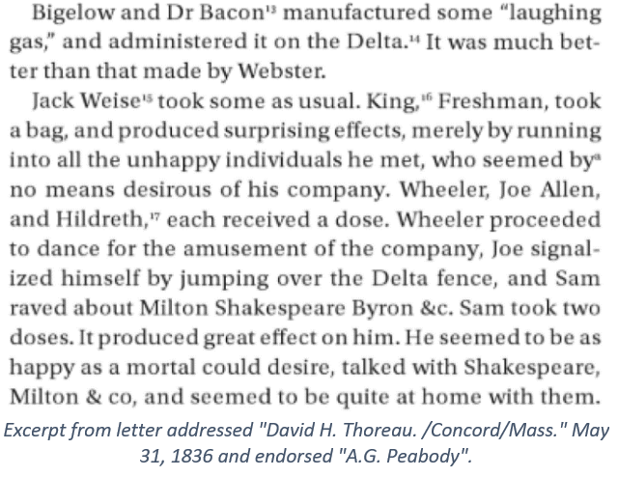
In fairness, two freshmen with the surname King were in the Harvard freshman class of 1835-6. Judge James Gore King, Jr. (1819-1867) was the second King. The Judge’s King family was far wealthier and more socially prominent than that of Geneva’s John King.
New York Supreme Court Judge James Gore King walked his sister Fredericka down the aisle in November 1857 at “Highwood,” the King palatial estate on the Heights of Weehawken in New Jersey. Just hours before the ceremony, a large portion of New York’s high society wedding guests had almost perished when their overloaded North River ferry Phoenix nearly capsized in a wintry squall.
James Gore King, Sr. was already a prominent man in 1836, making it unlikely that his son was not known to Peabody, whose Thoreau missive referred only to “King, Freshman.” The Senior James Gore King, like the Senior John King, was also a Harvard man.
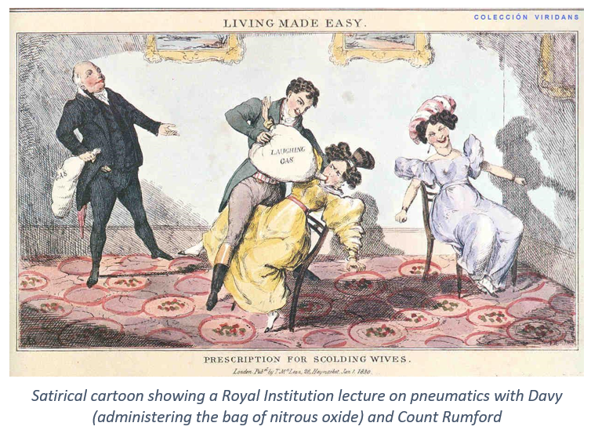
Sir Humphrey Davy (1778-1829) was a Cornish chemist, poet, and polymath. Although Priestly had discovered nitrous oxide, Davy experimented with it and became addicted. He was the one who coined the term “laughing gas.” Although he discovered many elements, including sodium and chlorine, he joked that his most significant discovery was his assistant Michael Faraday. Davy is buried in Geneva (Switzerland).
The “Webster” mentioned in the Peabody missive was John “Sky-rocket Jack” Webster, the Harvard Medical School lecturer and infamous murderer of Dr. George Parkman in 1849. The Peabody letter mentions Webster’s pyrotechnic displays but pans the quality of his bags of nitrous. Lawyers Daniel Webster and Rufus Choate (one of John King’s mentors) both declined to serve as John Webster’s defense counsel.

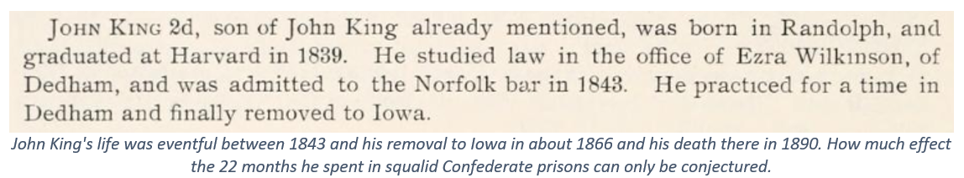

John King’s pre-Harvard education was likely similar to that of his Randolph friend Winslow Battles, who was also born in 1816. The two shared a fondness for music and were active members of the Stoughton Musical Society, founded in 1786.
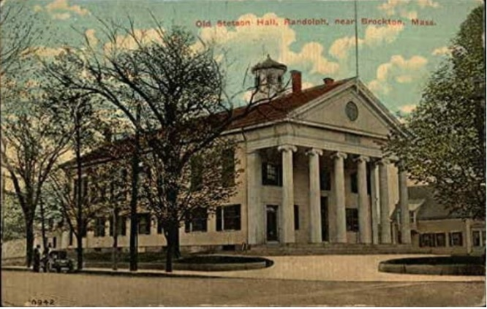
Dr. Ebenezer Alden presented to the Society 30 copies of the “Ancient Harmony.” Alden received thanks by the following motion, presented by John King, Esq., of Randolph, which was passed: “Whereas, Dr. Ebenezer Alden has this day presented to the Society a set of singing books to be kept for the use of the Society. Resolved, that the Society accepts with pleasure the valuable gift and tender their sincere thanks to the donor and that this resolution be placed upon the records of the Society.” The Secretary was to have charge of the books and have them properly marked and numbered; also sing from them at the annual sing, 25 December 1852, at Stetson Hall. This hall is still in existence at the corner of North Main and Union Streets. From this, we know John King was in Randolph in 1852. Winslow Battles became President of the Music Society from 1873-88. John King’s sister Julia Caroline married into the Alden family, whose original North American member was John of Mayflower fame.
To Dedham and Back to Randolph, MA
After he graduated from Harvard, John King studied law in the Dedham, MA office of Ezra Wilkinson. Ezra Wilkinson was born in Attleboro, Mass., 14 February 1805, and graduated from Brown in 1824. He studied law with Peter Pratt in Providence, RI, and Josiah J. Fiske in Wrentham, MA, and was admitted to the bar in Dedham in September 1828. Ezra practiced a short time in Freetown and Seekonk and removed to Dedham in 1835. He was District Attorney from 1843 to 1855, Representative 1841-51-56, and a member of the Constitutional Convention in 1853. In 1869 he was appointed Judge of the Superior Court and continued on the bench until his death in Dedham on 6 February 1882.
Judge Wilkinson was an avid book collector and a lifelong bachelor. He related that he still owned every pair of boots he had ever bought over 40 years, averring that if a pair ever went out of style, it was sure to come back into it in time. When his book collection was sold in a four-day auction in Boston in September 1882, the catalog was 134 pages long, containing 2577 items. Many of these pamphlets and tomes, of course, were purchased after John King’s time in his office. Many of them were classics, and some dated to the 16th Century. Wilkinson’s bibliophilic influence may be seen in John King’s proprietorship of the 800-volume circulating library housed in King’s Elgin law office in the late 1850s.
A John King Iowa obituary clipping of unknown date and origin states that John King also studied law with Rufus Choate, whose library contained 7,000 volumes. Choate was in the U.S. Senate from 1841-45. Choate did attend the Dane Law School in Cambridge in 1821, but his practice was primarily in Danvers, Salem, and Boston, though he was involved in cases tried in Dedham. Virtually all lawyers in the Boston area in the 1830’s and 1840’s no doubt at least heard Choate plead a case in a courtroom. Whether John King’s association with Choate was more than this has not been documented.
John King’s marriage and his and fledgling law practice in Dedham were both unsuccessful. John had become acquainted with Lucy Avery Bingham of Dedham, perhaps through a shared interest in music (their daughter Grace became a professional singer). Six years younger than John, Lucy was the youngest of the seven children of Pliny and Jerusha Avery Bingham. The first Bingham (Thomas) came to Norwich CT before 1696, and the Avery family of England arrived in Dedham before 1690.
John and Lucy were married in Dedham on 14 December 1843 by Dr. Eben Burgess. The couple had two children. Their first child, Isabella, was born in Randolph, MA, in January of 1845, and she died there in October of that same year. In 1846, John King was listed as an attorney and Justice of the Peace in Randolph. Grace Avery King was born in Randolph on 21 April 1847. By 1850 Lucy and Grace King were living with the widow Jerusha Bingham in Dedham. Ten years later, mother and daughter were still living in Dedham with Jerusha. By 1880 Lucy Avery King lived with her older unmarried sister Amanda on East Street in Dedham and told the census taker that she was a widow. But this was an assumption, or at least a guess, if not merely a hope.
Only a few glimpses of John King’s life in the 1840s have been found to date. That his family was interested in music, and more specifically, vocal music is evident. John remained an active member of the Stoughton Musical Society. “At Stoughton, in Hayden’s Hall, 1844, 25 December, it was voted that the ladies be invited to sing with the Society, their suppers to be paid for by the Society, and also that a committee of one from each town be chosen to invite Trebles to sing with the Society, and Mr. Glover, of Stoughton; Morse, of Sharon; Morse, of Canton; King, of Randolph, and French, of Braintree, be the committee. Eleven candidates were nominated for membership, and it was voted to sing from the “Academy’s Collection of Choruses,” and from Billings & Holden’s Singing Book. The motion to add soprano voices may have been purely based on musical considerations, but the minutes do not allude to any discussion.
The whereabouts of John King during the census of 1850 has not been identified. In September of 1850, Jon Wales, the Randolph Census Asst. Marshall found seven people living in the King home. At the top of the page was listed the widow Sarah Wales King, age 61. She doubtless was kin to the census taker. Equally sure is that someone and probably nearly everyone on that page knew where John King was. No one spoke about it. At least nineteen of the forty-two persons enumerated on page 111 of the Norfolk County Census were either John’s parent, sibling, niece, nephew, a sibling’s spouse, or other in-laws. Among them were a lawyer, a boot cutter, a clerk, a teacher, and a butcher (John’s brother Seth Turner King).
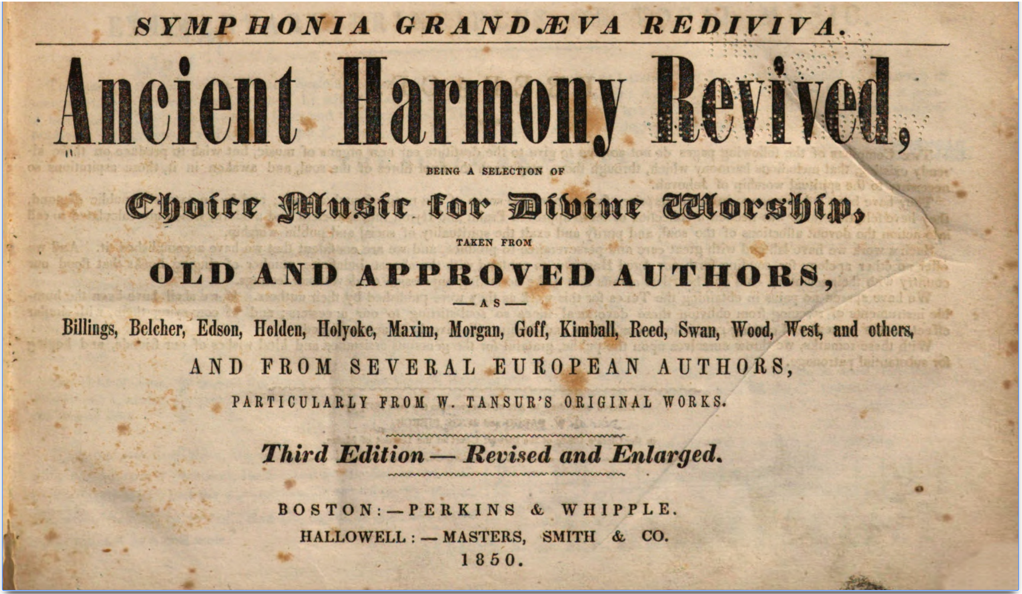
From the musical community’s records John King, Esq. can be placed in Randolph. The Battles family was part of the music scene. Winslow Battles’ brothers Jonathan and Dean were teachers before they joined the family boot business in Milton. Caroline Battles, the daughter of Jonathan and niece of Winslow, was a 32-year-old piano teacher in Boston in 1873 and living with her parents. Twenty-seven years later, she was still single and living in Boston on Dudley Street with her cousin Samuel Pierce.
Rockland, ME
John King’s whereabouts and activities in the 1850s are also incompletely known.
In 1855 John King was a notary and Justice of the Peace in Rockland, Knox County, Maine. In 1850 a sixteen-year-old named Ruth J. Battles was living in South Thomaston, Maine, about 3 miles southeast of Rockland with her parents and two brothers. By June 1860, only parents William, Mary, and brother John R. Battles (“idiotic” by a census notation) remained in the household in South Thomaston. Their Post Office was Rockland, Maine.
Maine was a territory of the State of Massachusetts until 1820 when Maine became a free state under the provisions of the Missouri Compromise that paired its entry into the Union with Missouri’s. Missouri was admitted as a slave state. One of the participants in the debates surrounding the Missouri Compromise was Massachusetts Congressman Timothy Fuller (1778-1835), who declared: “the right and duty of Congress” to restrict “the spread of the intolerable evil and the crying enormity of slavery.”
Did John King, Esq., remove to Rockland Maine because Ruth Battles was there, or did he meet her in Rockland? The latter seems the far likelier. Although Battles families were present in Dedham since at least the mid-18th Century, no close connection has been found between the Battles who were King’s Randolph acquaintances and the Maine Battles.
John King tried his hand as a merchant in Rockland, as the Gazette had numerous ads placed by him. Mostly his shop was referred to as “The Music Depot,” but he also sold firearms and fishing tackle in addition to books. The 1856 celebration of the 4th of July was “the most extensive celebration which ever took place here.” John King handled the pyrotechnics. Apparently, his association with John “Skyrocket Jack Webster” had resulted in some skill acquisition.
What did lead John King to Rockland in the early 1850s? Did a specific attraction lure him there? Or was the stigma of a failed marriage into a prominent family the cause of his departure? The Rockland name had only just been bestowed. The town of East Thomaston separated from Thomaston in 1848 and changed its name to Rockland in 1850. The city prospered as a port, an exporter of lime, and as a builder of ships.
By 1860 when Rockland became the shire town of the new County of Knox, a looming potential demand for legal services must have been long foreshadowed. But John King, Ruth Jane Battles King, and their three-year-old son John Reginald King (named after Ruth’s older developmentally challenged brother) had left “for the west” in 1857.
No Massachusetts record has been found of a divorce for John King and Lucy Bingham. Neither has a Maine record of a marriage of John King and Ruth Battles been located. And no birth record has been found for John Reginald King, the son of John and Ruth Battles King. John Reginald King, born in Maine, was with his parents in Elgin, Illinois, in 1860, according to the U.S. Census.
Timothy Fuller (introduced earlier), like John King and his father John King, had attended Harvard (class of 1801), and all three became Massachusetts lawyers. Two of Timothy’s offspring, Margaret and Arthur, had traveled to the central Fox River Valley of Illinois a few years before the Kings left Maine for Elgin, Illinois. Like John King, the Fullers have historical ties to Geneva, Kane County’s shire town.
So little is known of John King’s personality traits that temptation exists to examine those of his contemporaries who left behind more evidence. Timothy Fuller is an example. “For despite his arduous efforts to curb his appetite (“especially;” he wrote his wife … for “the fair bosom”), Timothy was always a would-be ladies’ man with an appreciative eye for a pretty face, not only in his younger single years as a student and teacher but also later…His Harvard-era diary covers the brief period he taught at Leicester Academy (one of the few that accepted women) and reveals his “ample appetite” for the other sex...Later, Timothy delighted in having been selected by “several ladies” to walk and later talk with them at Judge Walker’s house; he confesses how, amid a “world of sighs & k--s,” he regretfully took leave of them.
John King’s position along the continuum of such “appetites” cannot be guessed. Fuller’s letters only serve to show that even in Calvinistic New England, some men at least were willing to write about their longings. John King’s passions remain mostly mysterious, apart from books, music, fireworks, and the abolition of slavery.
John King shared an abiding disdain for slavery with Timothy Fuller. John left Massachusetts for free-soil Maine just as the Missouri Compromise of 1820 was effectively repealed by the Kansas-Nebraska Act of 1854. In a few short years, this Act, coupled with the disastrous and unfathomable 1857 Dred Scott v Emerson decision by the Roger Taney U.S. Supreme Court, would culminate in the Civil War.
Why did John and Ruth King head west to Elgin, Illinois, in 1857-8? Their son John R. King had been born in Maine and was listed as age three on 29 June 1860 by the census taker. King’s professional “tombstone ad” was first placed in the Elgin Gazette in April of 1858.
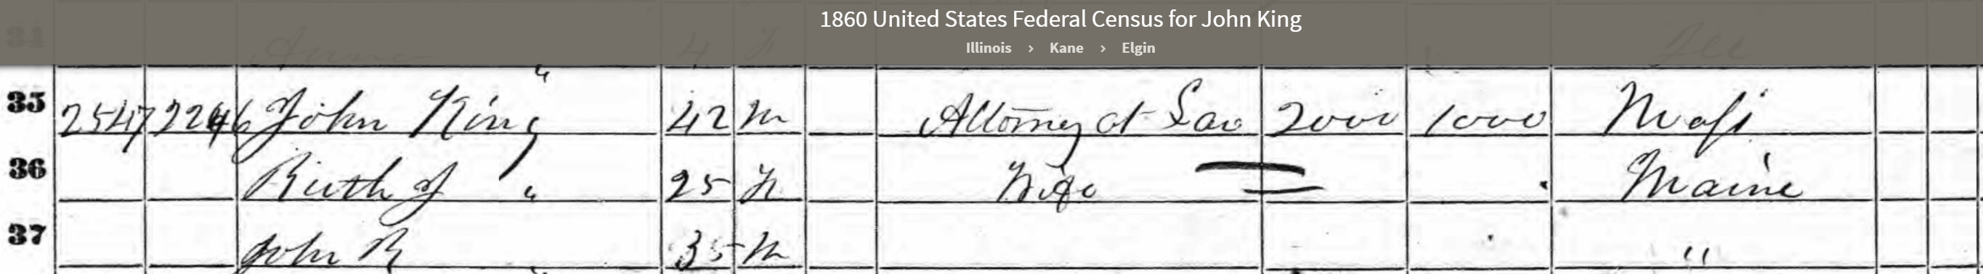
John King may have visited the Elgin area earlier in the mid-1850s. George W. Battles, possibly Ruth’s brother George, was appointed Postmaster at Romeo in McHenry County in December of 1854, replacing N.C. Dodge. Thirty-three post offices existed in McHenry County in 1856 (Kane had 28). Romeo P.O. was likely located in the southeast corner of Dunham Township of McHenry County. The immediate vicinity was an enclave of interrelated families. Jonathan Wells’ wife Catherine DeGroat was the Aunt of Mrs. Samuel Chase. The Chase, DeGroat, and Wells families came as one party to Dunham Township in 1842.

John King’s sister Sarah Wales Turner Howard (1818-1886) and her husband Lucius Howard were the proprietors of the famous “Waverly House” hotel in Elgin in 1857. Lucius had begun his career in hostelry at the 100-year-old Randolph Inn in 1848 and changed the name to Howard House. Later in Abington MA he ran the “King House” until he removed to Chicago in 1855 and again was an innkeeper.
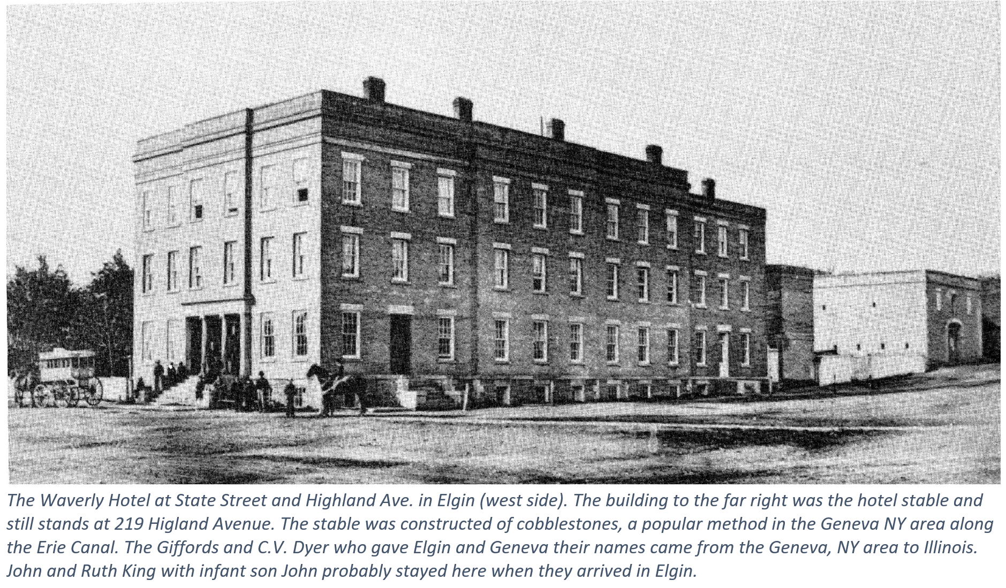
William Currier Kimball built the Waverly House at State and Highland Avenue in 1853. Ferslew’s Directory of 1857 listed “Kimball & Howard proprietor Waverly House.” The Freeport Dailey Journal reported on 15 May 1856 that the Howards “had become” the Waverly proprietors after a stint at the Angiers Hotel in Cleveland. “Skyrocket John” King was the pyrotechnologist still back in Rockland ME on the 4th of July 1856.
The Camanche Iowa tornado of 1860 that killed fifty and flattened the town may have left a clue as to why John King was in Geneva. Lucius Howard was in Clinton IA on the 6 June 1860 in the role of hotel proprietor. Lyons was a Mississippi River town about fifteen miles north of Camache, also on the River. The Mississippi is relatively narrow between Fulton on the Illinois side and Lyons (now part of the City of Clinton), so a ferry operated there beginning in the mid-1830s.
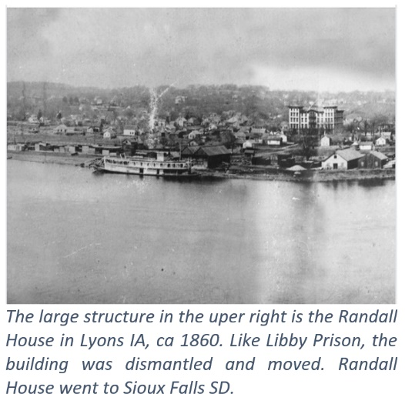
In the immediate aftermath of the disastrous tornado, the people of Clinton and Lyons formed a relief committee of five. One was the hotel proprietor Lucius Howard. Lucius Howard moved to Clinton, Iowa, in 1859 to conduct the “Iowa Central House.” The financial collapse of 1857 was unkind to hoteliers. The same Civil War draft census of the summer of 1863 that found Geneva’s John King in Libby Prison instead of Geneva listed Lucius Howard in Lyons, IA as a grocer. Howard must have gazed longingly at the new 350 room Randall House built by the Randall Brothers of Baltimore on speculation in 1856. The crash of ’57 was so severe that, despite its five-story brick outhouse, Randall House never found an operator in Lyons. The Lincoln Highway crossed the Mississippi at the Lyons-Fulton narrows bridge from 1891 until 1975 when it was demolished.

Ancestry.com. U.S., School Catalogs, 1765-1935 [database on-line]. Provo, UT, USA: Ancestry.com Operations, Inc., 2012. https://www.ancestry.com/imageviewer/collections/2203/images/32761_622204_0352-00016?ssrc=pt&treeid=156384512&personid=262063405466&hintid=&usePUB=true&usePUBJs=true&_ga=2.139521843.1685814643.1601735120-1659798538.1590921733&pId=921324
Stevens, K. Descendants of Henry Wilson of Dedham, Massachusetts. K. Stevens, 1996. p190-1. https://books.google.com/books?id=a6NbAAAAMAAJ
Joslyn, p491. Later, from 1846 to 1850 Wilson was the partner of Silvanus Wilcox in Elgin. The Crackerbarrel. Jan. 2019 Vol 56, No1, p5.
The History of Elgin, Kane County, Illinois 1835-1875. Lord & Bradford, Elgin,Il, 1875. p88. https://archive.org/search.php?query=external-identifier%3A%22urn%3Aoclc%3Arecord%3A1046534457%22
Elgin Weekly Gazette, 5 Dec 1861, p1.
John King graduated from Harvard in 1839. For Wilson bio see Durant, P.A., H.C. Bradsby, and S.W. Durant. Commemorative Biographical and Historical Record of Kane County, Illinois: Containing Portraits and Biographical Sketches of Prominent Citizens, Governors of Illinois, Presidents of the United States, Also Containing a History of the County. Beers, Legget,1888. p198-9. School, Harvard Law, and Harvard Law School. Association. Quinquennial Catalogue of the Law School of Harvard University. The School, 1920. p272. https://books.google.com/books?id=9lNMAQAAMAAJ https://books.google.com/books?id=p454kgAACAAJ
Wilcox, C.M., and M.R. Wilcox. History of the Mexican War. Church News Publishing Company, 1892. p661. https://books.google.com/books?id=wyMuAAAAYAAJ
LeBaron, p376.
King, Harvey Briggs. The King Genealogy, and Its Branches, Moultons, Sedgewicks and Shaws, and Their Descendants, Bearing Other Names. Hartford, Conn.: Plimpton mfg. co. print., 1897. p11.
“Puritan migration to New England (1620–1640)," Wikipedia, The Free Encyclopedia, https://en.wikipedia.org/w/index.php?title=Puritan_migration_to_New_England_(1620%E2%80%931640)&oldid=943826046 (accessed May 7, 2020). Not to be confused with: “Great Migration (African American)," Wikipedia, The Free Encyclopedia, https://en.wikipedia.org/w/index.php?title=Great_Migration_(African_American)&oldid=953905055 (accessed May 7, 2020).
Hingham (Mass.: Town), Thomas Tracy Bouvé, Edward Tracy Bouvé, John Davis Long, Walter Lincoln Bouvé, Francis Henry Lincoln, George Lincoln, et al. History of the Town of Hingham, Massachusetts. 3 vols. Hingham: Pub. by the town, 1893. Vol II p 407.
“Hingham nurse’s work as general contractor recognized on ‘This Old House’ - News -,” The Patriot Ledger, Quincy, MA. 23 Aug 2011.
The English Puritan Plymouth Colony found open agricultural lands that had been cleared by Native Americans but depopulated of the Natives because of the epidemics brought to North America by the Europeans. Conforti, J.A. Imagining New England: Explorations of Regional Identity from the Pilgrims to the Mid-Twentieth Century. University of North Carolina Press, 2003. https://books.google.com/books?id=aUzqCQAAQBAJ.
The Last Will and Testament of John King. filed January 2, 1891 set for probate January 28, 1891 at 10:00 AM. John S friendly, Clerk of District Court, Boone County Iowa.
De Wolfe Howe, M.A. The Humane Society of the Commonwealth of Massachusetts: An Historical Review, 1785-1916. Humane Society at the Riverside Press Cambridge, 1918. p295. https://books.google.com/books?id=_AQ1AQAAMAAJ
In the Harvard Class of 1801 was Timothy Fuller, the father of transcendentalist Margaret and Unitarian Minister Arthur Fuller. Margaret visited Geneva in 1843 and Arthur participated in the 1844 dedication of the Geneva Unitarian Church built by Augustus Conant. Both Arthur and Augustus were Civil War Chaplains, and both died early in the War from the effects of battlefield exposure.
Harvard University. Porcellian club. [from old catalog]. Catalogue of the Honorary and Immediate Members and of the Library of the Porcellian Club of Harvard University. Cambridge: Metcalf and company, printers, 1854. p15.
Davis, William T. Bench and Bar of the Commonwealth of Massachusetts. 2 vols. Boston: The Boston history company, 1895. Vol 2, p197,198.
Thoreau, H.D., and R.N. Hudspeth. The Correspondence of Henry D. Thoreau: Volume 1: 1834 - 1848. Princeton University Press, 2014. p4. In 1841 Margaret Fuller, as the editor of the Dial famously rejected a Thoreau poem “The Mountain.”. But she did so through a lengthy letter of constructive criticism which can be accessed here: https://www.brainpickings.org/2015/06/30/margaret-fuller-thoreau-letter/
Van Rensselaer, J.K., and F.F. Van de Water. The Social Ladder. H. Holt, 1924. p178-183. https://books.google.com/books?id=cZgsAAAAMAAJ
KING, JAMES GORE, (son of Rufus King and brother of John Alsop King), a Representative from New Jersey; born in New York City May 8, 1791; pursued classical studies in England and France; returned to United States; was graduated from Harvard University in 1810; studied law at the Litchfield Law School; served in the War of 1812 as assistant adjutant general of New York Militia; engaged in mercantile pursuits in New York City in 1815 and in banking in Liverpool, England, in 1818; returned to New York City in 1824 and engaged in banking, with residence in Weehawken, N.J.; president of the Erie Railroad in 1835; elected as a Whig to the Thirty-first Congress (March 4, 1849-March 3, 1851); declined to be a candidate for renomination in 1850; resumed the banking business; died at his country place, ``Highwood,'' near Weehawken, N.J., October 3, 1853; interment in the churchyard of Grace Church, Jamaica, N.Y. https://bioguideretro.congress.gov/Home/MemberDetails?memIndex=K000203 John Gore King (’39) was a member of the Alpha Delta Phi fraternity. The Alpha Delta Phi 1832-1882. The Fraternity, [ND]. pXXXIV.
https://en.wikipedia.org/wiki/Humphry_Davy
Wikipedia, The Free Encyclopedia, https://en.wikipedia.org/w/index.php?title=Parkman%E2%80%93Webster_murder_case&oldid=954073835 (accessed May 27, 2020).
History of Norfolk County, Mass. Vol. 1, p4.
http://www.stoughtonhistory.com/1929historyto1886.htm [5/6/2020 6:20:25]
Alden, Ebenezer. Memorial of the Descendants of the Hon. John Alden. S. P. Brown, 1867. p135. https://books.google.com/books?id=aDYxAAAAMAAJ
Society, New England Historic Genealogical. Memorial Biographies of the New England Historic Genealogical Society. The Society, 1907. p89-90. https://books.google.com/books?id=A3MtAAAAYAAJ
Davis, W. T. (William Thomas). (1900). History of the judiciary of Massachusetts: including the Plymouth and Massachusetts colonies, the province of the Massachusetts bay, and the commonwealth. [Boston]: The Boston book company. 1900. P256-257.
Wilkinson, E. Catalogue of the Private Library of the Late Hon. Ezra Wilkinson ... Including a Very Rare Collection of the Statute Laws of Massachusetts ...: To Be Sold by Auction ... Sept. 19th, 20th, 21st and 22d, 1882, in the Library Salesroom ... Boston ... Sullivan Brothers & Libbie, Auctioneers. W.F. Brown & Company, printers, 1882. https://books.google.com/books?id=Gi8RAAAAIAAJ.
Burt, Find a Grave Memorial 23087752, 25 Nov 2007.
John King Jr of Randolph joined the “Old Stoughton Musical Society” in 1839. Forty years later his long-lost daughter Grace Avery King joined the same Society. http://www.stoughtonhistory.com/osmsmembers-jn.htm
Pliny Bingham was an ensign in Captain Guild’s Company of Massachusetts Militia during the War of 1812. Fifty years later his bounty warrant was used to purchase 40 acres in Coles County, Illinois. Jerusha conveyed the Warrant to Samuel White who in turn conveyed it to Joseph Smith. All this was ratified by the (probably mechanical) signature of President Abraham Lincoln in 1863. Military Land Warrant, Vol 935, p438. 20 May 1863.
The early records of the town of Dedham, Mass., 1672-1706: a complete transcript of the town meeting and selectmen's records contained in book five of the general records of the town, being volume five of the printed records of the town. unknown: unknown, 1899. p229.
Massachusetts, Death Records, 1841-1915. ancestry.com.
Massachusetts Register for 1846. Boston: James Loring, 1846. p86,88.
U.S. Census, Year: 1850; Census Place: Dedham, Norfolk, Massachusetts; Roll: 330; Page: 244B.
Billings, W., O. Holden, Boston Billings, Holden Society, Capen Marsh, and Lyon. The Billings and Holden Collection of Ancient Psalmody,: Being a Collection of Psalm and Hymn Tunes, Anthems, &C. Published as Originally Written. : Principally Selected from Ancient Authors, Together with a Few Tunes Never before Published. In Which May Be Found Many Beautiful Pieces from Billings, Holden, Law, Holyoke, Mitchell, Swan, Belknap, Kimball, French, Brown, Holt, Wood, and Other Eminent American and European Authors. : Published under the Patronage of the Boston Billings and Holden Society. Marsh, Capen & Lyon, 133 Washington Street., 1836. https://books.google.com/books?id=4b21tgAACAAJ
http://www.stoughtonhistory.com/1929historyto1886.htm [5/6/2020 6:20:25]
Boston Directory, 1873, 1900 US census.
Eaton, C. History of Thomaston, Rockland, and South Thomaston, Maine, from their first exploration, A. D. 1605; with family genealogies. Hollowell, Maine. 1865 vol II p117,121, 130.
Year: 1850; Census Place: South Thomaston, Lincoln, Maine; Roll: 259; Page: 135B.
Year: 1860; Census Place: South Thomaston, Knox, Maine; Page: 355; Family History Library Film: 803443.
Wilentz, Sean. “Jeffersonian Democracy and the Origins of Political Antislavery in the United States: The Missouri Crisis Revisited.” Journal of The Historical Society 4, no. 3 (2004): 375-401. p387.
At least this was the recollection in the Gazette in its Centenniel Edition of 4 July 1876. Be it remembered that Knox County was named for its most famous resident, General Henry Knox (1750-1806), who, as Washington’s Chief of Artillery, knew something about “the [Congrieve] rockets red glare.”
Murray, M.M.G. Margaret Fuller, Wandering Pilgrim. University of Georgia Press, 2012. p10. https://books.google.com/books?id=I9fqJeLifJEC
The Act’s passage triggered the conflict known as Bleeding Kansas, over whether Kansas would enter the union as a free or slave state. Proslavery “Missouri Ruffians” and antislavery Northerners rushed to the Kansas territory determined to influence the vote on statehood. Their struggle, characterized by rigged elections and savage fighting, led to a near civil war, including the sacking of Lawrence, Kansas, by slavery supporters and John Brown’s retaliation at Pottowatamie, Kansas, driving the two sides even further apart. Both King and Joslyn ended up in Missouri trying to staunch the blood flow by military force. It is not an accident that Geneva has two adjacent streets named Kansas and Nebraska. Many mid-19th century Genevans moved to Kansas and Nebraska in part due to the national effort to change their demographics towards abolitionism.
The entry was apparently erased and corrected to “3” and entries below it were likewise altered suggesting correction of a transcription error – census takers were required to submit a copy of their field noations. Year: 1860; Census Place: Elgin, Kane, Illinois; p536; Family History Library Film: 803191.
Commission, United States Civil Service. Official Register of the United States. U.S. Government Printing Office, 1855. p344. https://books.google.com/books?id=5NPrKp8rIpkC
Leech, D. D. T. "Post Office Directory." v. New York: J. H. Colton and company, 1856. p44,45.
George Battles was the Romeo Postmaster for only about a year. His successor was Jonathan Wells who bought a farm in southwest Dunham Township about five miles north of Marengo in 1844. Wells went to California in 1850 (and kept a diary of his 4-month journey) and returned to his Dunham Township home in 1854. History of McHenry County, p364. Dunham Township was originally named Byron but as another Byron existed in Illinois a new name was needed in 1850. The task of selecting the name was given to Solomon J. Dunham, Esq., a Justice of the Peace.
Howard Genealogy, p129.
History of Elgin, 1875. p93. https://historicelgin.com/219-w-highland-avenue As part of a conspiracy designed to foil future historians Elgin, like other towns, changed the names of its streets. In 1984 Galena Road became W Highland Avenue and Summit Street bcame State Street. https://www.cityofelgin.org/531/Street-Name-Changes In 1859 the Waverly House was on the corner of Main and Galena. Kane County Directory, 1859-60. Chicago, Il: Bailey, 1859. Main Street became State sometime in the distant past. Alft, E. C. Elgin : An American History, 1835-1985. 1st ed. Elgin, Ill.?: Crossroads Communications, 1984. p
William C. L. E. Ferslew, comp. Ferslew's Kane County Gazeteer, Directory and Business Advertiser, 1857, Geneva, Illinois, 1857. p121.
Freeport Daily Journal, Freeport, Illinois, 15 May 1856, Thu, p.2.
History of Clinton County, p Co, Western Historical. The History of Clinton County, Iowa: Containing a History of the County, Its Cities, Towns &C., Biographical Sketches of Citizens. Western historical Company, 1879. p403. https://books.google.com/books?id=pYQUAAAAYAAJ
With the 1855 announcement that a railroad was to cross the Mississippi several miles south of Lyons at Little Rock Island in the river, the Iowa Land Company was organized. This company purchased Bartlett’s original tract opposite Little Rock Island, re-platted the town of “New York”, and renamed it Clinton in honor of DeWitt Clinton, Governor of the State of New York. The company’s Iowa Central Hotel and Block (now demolished) was the first substantial structure in Clinton. The Chicago, Iowa and Nebraska (C&IN) Railroad was formed with the intent to cross the river at Clinton. Department of Community Development, City of Clinton, Clinton, Iowa, An Architectural Heritage (1980). http://iagenweb.org/clinton/history/arch/hist.htm
https://www.facebook.com/photo.php?fbid=10222887132275722&set=gm.2960521774033551&type=3&theater

