The Wars of John King, Esq.

From the Kane County Courthouse to “A Low, Dirty Place”
One Genevan’s Star-Crossed Heroic Brawl Against Injustice

by
Rodney B. Nelson, III, M.D., F.A.C.P.

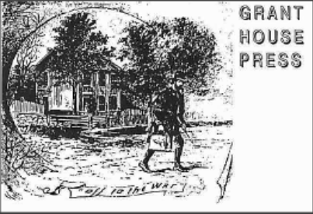

23 Kane Street
Geneva, IL 60134

©Rodney B. Nelson, III, M.D., F.A.C.P., 2020
Introduction
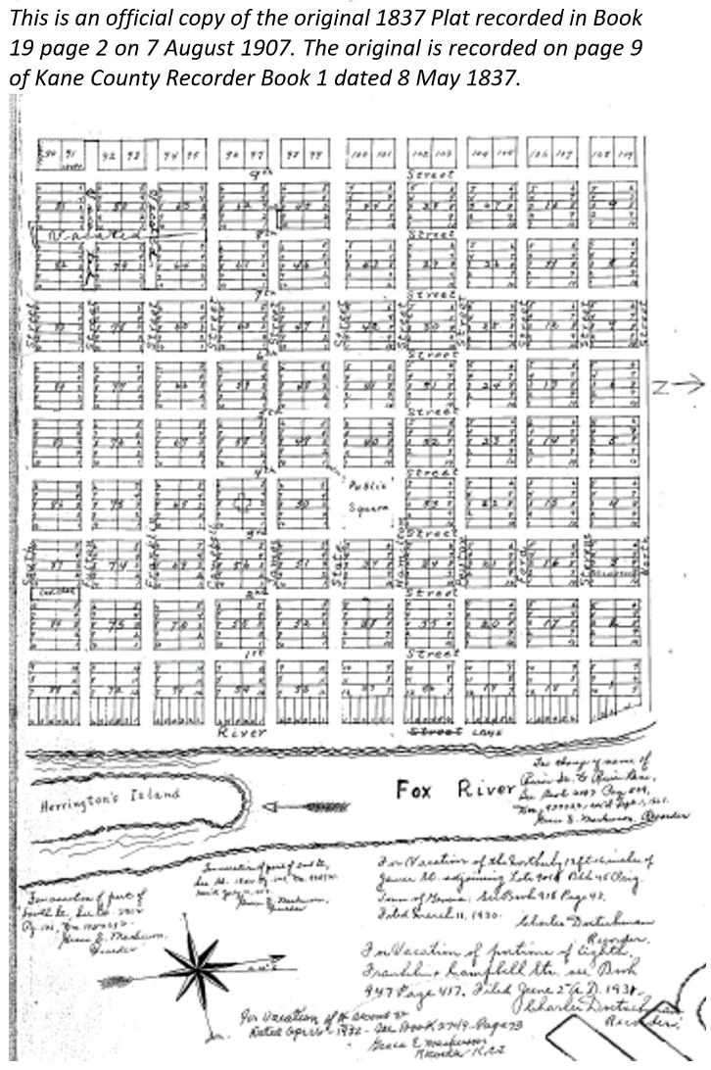
What kind of place was Geneva, Illinois, in the spring of 1861? The town, platted on 8 May 1837, was not twenty-five years old when a vigilante mob of Elginites descended upon Geneva on 23 April 1861 bent on seizing property by force. This gang was no posse comitatus—not a man among them was vested with police power. The Kane County Sherriff (an Elginite) was consulted, but he stood down as a brawl ensued.
Geneva’s defenders were lead by John King. King and the looters’ chief, Ed Joslyn, were both lawyers. Just a few weeks earlier Joslyn had finished his four years as Kane County State’s Attorney.
For safekeeping, the property in question had been deposited by King in the grand jury room of the Kane County Courthouse, a fortress-like limestone building standing on South 3rd Street between James and Campbell Streets that had just been completed in 1857. No negotiations took place. Edward Swain Joslyn, albeit battered and bruised, left Geneva with the stolen property that night. His sons wrote a history of Kane County. Ed Joslyn’s sons thought this of the early Genevans:
“Andrew Miles, a Hoosier, came to the [Geneva] Township in 1833 or 1834. Mrs. C.B. Dodson, then Miss. Warren, rode in a lumber wagon in April 1834. Frederick Byrd arrived in 1834, but subsequently moved to near Rockford. These and other early settlers were largely from Indiana, and were a simple and honest people.” R.W. & F.L. Joslyn, Elgin Illinois
This quote is “largely” true only because Indiana was the last place of residence for many “first wave” Geneva settlers, including New York native Daniel Shaw Haight. However, of the four persons named by the Joslyns, one was born in Massachusetts, one in Pennsylvania, and two in New York. Only Andrew Miles had ever even lived in Indiana. The other three were linked to the Captain C.B. Dodson family. Genevans Captain Dodson and Captain King started down the same patriotic path in the spring of 1861. Their martial tours ended in different places at different times under very different circumstances.
One of the Joslyns’ archetypal Genevans, Frederick Bird, married Louisa Warren, Harriet Warren’s (Mrs. C.B. Dodson) sister, in NY in 1824. The Birds did move to the Rockford area. More precisely, he and Louisa Warren Bird moved in 1835 to near Roscoe in Winnebago County, IL, to a family enclave known as “[Frederick] Bird’s Grove.”
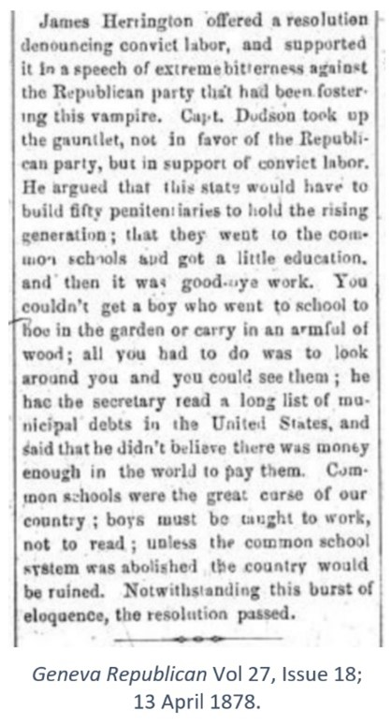
“Hoosier” Andrew Miles was born on 4 May 1809 in Tioga County, NY. His parents moved to Madison County, Indiana, and there Andrew Miles married Sabrina Cory in 1830. The couple, along with Andrew’s widowed father, also named Andrew, came to Kane County in 1833. The elder Andrew Miles became Geneva’s and Kane County’s first settler to pass away in 1836. “Miles, who is represented by our worthy informant [C.B. Dodson] as a good-natured, lazy and ignorant native of Indiana [sic], had taken up a claim upon the East Side and was living in a miserable shanty, upon Capt. Dodson's arrival, but was bought out by him previous to 1835.”
Sabrina Cory Miles’ brother, Samuel Cory, married Abigail Starnes. Abigail Starnes’ sister Mary married Daniel Shaw Haight, Geneva’s first proprietor. The families of Haight, Miles (including Andrew, Sr. and Jr.), and Cory (including Samuel, Sr. and Jr.) all arrived in Geneva via Fountain Co. Indiana (through Hickory Grove, IL, in 1831-2) in 1833-4.
Samuel Cory, Sr. had been the Sherriff of Madison County, IN, in 1824 when six white men massacred and robbed a group of peaceful Native Americans. As the very first Madison County Sheriff, Samuel Cory (born in Lyme, CT in 1788) captured and incarcerated five of the six perpetrators and held them for trial despite numerous threats on his life. That trial resulted in the first U.S. hangings of white men for the murders of Native Americans.
The mother of Sheriff Samuel Cory was Mary Molly Bingham. John King first married Lucy Avery Bingham. Both women were descendants of Deacon Thomas Bingham (1649-1729), the first American Bingham. Among Geneva founders, Samuel Cory stood tall, perhaps even the tallest, as a champion of justice.
Geneva did not influence John King in his youth, nor did his brief presence influence Geneva much, though his values and patriotism struck a chord with some townsmen. In fact, each took little notice of the other. That is except when John and Ruth King named a daughter “Geneva,” and during the brief and brutal 1861 “War at Home.”
On these pages a focus is on two Geneva and Kane County groups: the first wave of founders/settlers and the later group of historians who wrote of the former a few decades later. The specific pioneers in the first group who informed (and sometimes misinformed) the historians in the second group combined to create a durable and oft-repeated narrative.
The Black Hawk War of 1832 marked the upward inflection of the white man’s settlement of Northern Illinois. Many of the men named above had been combatants. What had been a trickle became a flood after “The Massacre at Bad Axe.” Wars are historical mileposts. Beginning this composition with a Civil War-era anecdote, “The War at Home” might well seem a peculiar place to start given the just stated aim. John King was barely even a Genevan, though he is indelibly identified as one by an extraordinary event.
John King’s story falls within one of local historiography’s most treacherous transitions: when the lives of the hoariest history makers overlap with those of the budding but often amateur local historians. Much like the former Hoosier Sheriff Samuel Cory, Captain John King has been lost to Geneva history. John King ranks with Samuel Cory in stature and not just because King was 6’3”. Both were advocates for justice and equality before their beliefs were widely viewed as particularly virtuous.
Consider that Elgin’s Joslyn brothers, the writers of the above quotation that so inaccurately describes Geneva’s founders, were among the last Kane County historians who could have drawn directly on the oral history of Geneva. The names of many of those early Genevans and Elginites appear in John King’s war story. Also, the Civil War tale illustrates how interconnected those early settlers were across the entire Fox Valley region.
The quote in this introduction is from the Joslyns’ ponderous 1908 two-volume History of Kane County. Rudolphus Waite Joslyn and his older brother Frank L. Joslyn were the co-authors. Both were attorneys. Frank Joslyn was the Kane County States’ Attorney from 1892 to 1900. The Joslyns were at least professional analysts of evidence, if not professional historians.
The Joslyns’ “simple and honest people” judgment pertains to four Genevans declared to be examples of Geneva “early settlers.” From this quartet, the Joslyn brothers drew conclusions about the intellects and scruples of Geneva’s founders. How did they select the four individuals? How did they define “simple”? How honest were they? As noted, three of the four were members of the Dodson-Warren clan. Surely this bias alone renders the tiny sample wildly unrepresentative of the larger group.
Rudolphus Waite Joslyn (1866-1939), the Elgin, Illinois attorney, and the son of Kane County State’s Attorney Edward Swain Joslyn, wrote several books, including a series of pamphlets on “Normalism,” the philosophy of happiness. His bestseller was a treatise on personal injury law. He also wrote on labor issues. His Twelfth Commandment starts with this clumsy sentence describing the Haymarket Riot era of violent labor relations during which Joslyn practiced law: “That the industrial situation is rapidly approaching a period in which what has long been presented as argument will take form in action, is becoming more evident from year-to-year.” His “thou shalt not profit from the labor of other men” commandment belies his father’s lukewarm opposition to slavery and is far more akin to John King’s passionate abolitionism. Brother Frank Joslyn may have been the more gifted wordsmith.
Captain Christian Bowman Dodson was a remarkable Genevan who was lauded as a reliable source by many early local historians. However, C.B. Dodson was not a Geneva founding father. He first lived in what would become Kane County in Clybourneville on the Fox River below Batavia and his connections there were with the Napers and Warrens to the east on the DuPage River.
After his marriage to Harriet Warren in 1837 the couple lived in Lockport and then in Chicago. He did not live in or near the Village of Geneva until the winter of 1838-9 at the earliest (his twin sons Charles Hogan and Julius Warren Dodson were born in Chicago on 1 Dec 1838). Harriet wrote that they went to Geneva only because of financial reversals due the Panic of 1837. The Dodsons’ first Geneva home was not in the platted village and was on the east side of the Fox River about a mile south of Geneva on the property he had purchased from Andrew Miles. By 1850 Harriet and the children were living in Winfield Township while C.B. Dodson was on one of his two gold rush trips to California.
“The War at Home” was an event where the Dodson clan was prominent. The capriciousness of the historical record becomes evident. Some actors in the episode became legendary local heroes. Others became villains. Most faded into history. The “War at Home” occurred at the outbreak of a national and local tragedy: The Civil War.
Geneva Calvary Captains C.B. Dodson and John King were among the first Genevans to respond to the call by the newly inaugurated President Abraham Lincoln to rescue the Union from traitors. Both men attempted to raise companies in Geneva. Dodson succeeded (but not until King was already at the front) and added to his by then already exalted local historical stature, though his war service was relatively brief. John King was forcefully thwarted and demonized for his patriotic efforts, though many as yet unnamed Genevans came to his aide.
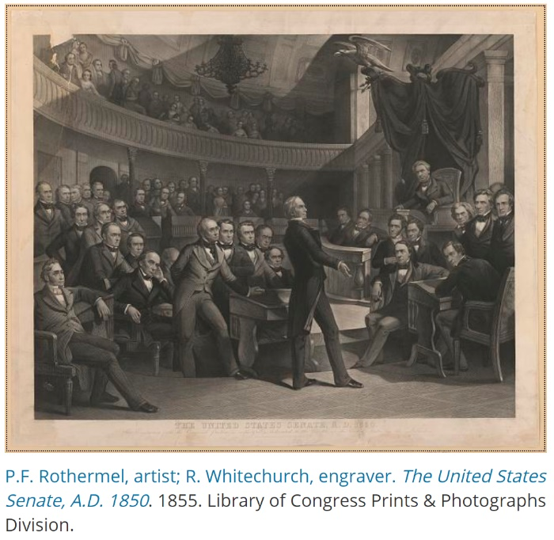
C.B. Dodson named a son Henry Clay Dodson after the slave-owning “Great Pacifier” (depicted to the left). John King named a son Lincoln King. Antislavery zeal existed on a continuum. Among the most zealous in the Fox Valley were Rev. A. J. Joslyn in Elgin, Rev. Augustus Conant who lived and preached in Geneva and also preached in Elgin, and John King, Esq., who lived and practiced law in Geneva and Elgin.
Senator Henry Clay speaking about the Compromise of 1850 in the Old Senate Chamber. Among those shown are 2. Daniel Webster, 3. Thomas H. Benton, 4. Lewis Cass, 5. William H. Seward, 6. Millard Fillmore, 7. William L. Dayton, 9. John C. Calhoun, 13. Stephen A Douglas, and, 16. Salman P. Chase.
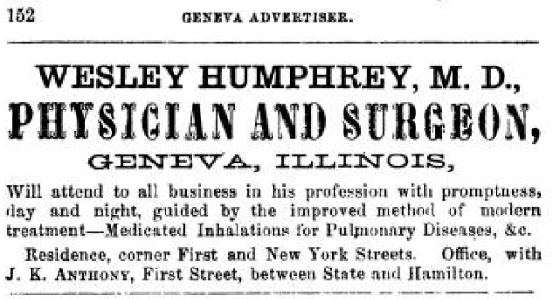
Besides John King there was another “forgotten man” in Geneva in 1861 who could be named with the above four zealous abolitionists: Dr. Wesley Humphrey. Doubtless the Doctor and John King both knew of John Brown, the Doctor’s kinsman and the quintessential abolition zealot. Of John Brown, John King’s Harvard classmate Henry David Thoreau wrote: “He did not go to the college called Harvard, good old Alma Mater as she is. He was not fed on the pap that is there furnished. As he phrased it, "I know no more of grammar than one of your calves." But he went to the great university of the West, where he sedulously pursued the study of Liberty, for which he had early betrayed a fondness, and having taken many degrees, he finally commenced the public practice of Humanity in Kansas, as you all know. Such were his humanities and not any study of grammar. He would have left a Greek accent slanting the wrong way, and righted up a falling man.” Many similarities can be found between the war time careers of King and Humphrey.

The “winner” of the “War at Home,” was Elgin’s Edward Swain Joslyn. Edward’s brother, Rev. Adoniram Judson Joslyn, edited the Elgin Gazette when the Geneva affray occurred. Christian B. Dodson’s brother, Dr. Bixby E. Dodson, championed Edward Joslyn in print in the Gazette. Many Gazette issues of 1861 survive and are readily available in digital form. Geneva’s newspaper voice at the time, The Kane County Advertiser, also addressed the event. John Wilson, the Advertiser editor, wrote what must have been a spirited defense of Geneva and of John King, but a copy of that issue has not yet been found.
“Newspapers are the second hand of history. This hand, however, is usually not only of inferior metal to the other hands, it also seldom works properly.” This philosopher Arthur Schopenhauer quote has been logically enlarged by the observation: “For if the newspaper is the second-hand in the clock of history, the individual is the second-hand in the clock of humanity.” John King was one such individual.
Schopenhauer and Henry David Thoreau died within a year of each other, but each was unaware of the others’ existence even though their philosophies bore similarities. John King and Henry David Thoreau, born a year apart, were schoolmates at Harvard and thus were calcined in the same Unitarian-centric crucible. (The allusion to chemistry might become more clear later.) Thoreau was raised as a Unitarian but died in 1862 as a Transcendentalist. John King loved to sing hymns but his name has not been found on any church roll.
Thoreau’s friend “Waldo” Emerson sent Henry to the beach of New York’s Fire Island in July of 1850 to search for the remains and property (most particularly manuscripts) of Margaret Fuller. The latter tragically drowned along with her Italian significant other and their child after the wreck of Elizabeth on 19 July 1850. Delayed by a two-week quarantine at Gibraltar after a smallpox epidemic killed its captain, Elizabeth broke up in a storm just 50 yards from the NY shore.
The heart-broken Thoreau found only a few of Fuller’s empty trunks, artifacts, and papers. Looters had picked the shore clean. Thoreau’s description of his forlorn and melancholy search came to light only in 2015 and now resides at Harvard. Genevans of a historical bent will remember Margaret Fuller and her brother Arthur were Geneva visitors in the 1840s, Arthur as a fellow clergyman and friend of Augustus Conant. Both of those men also studied at Harvard.
Portrait of John "Osawatomie" Brown after page 302 of The Humphreys Family of America, 1883.
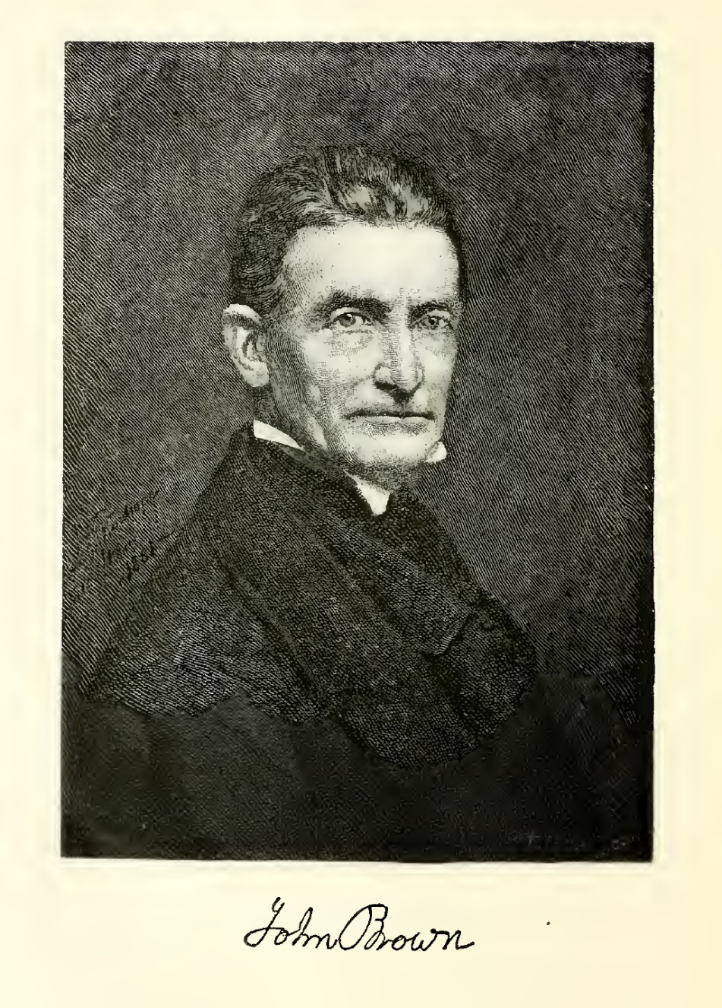
Fickle fate tossed the complex, flawed, yet heroic John King into the ash bin of history. The author hopes to partially atone here for this oversight by resetting history’s clock back for a few seconds in order to replay a meager glimpse of his life.

Chapter I: The War at Home

“The Collision” as Reported Locally

History writers non-randomly select anecdotes to include and those to omit. Not surprisingly, the Joslyn brothers’ Kane County history does not mention “The War at Home” of 23 April 1861. Their father Edward Swain Joslyn had played a leading role in that inglorious episode in Elgin, Geneva, and Kane County history.
The trouble began with this urgent terse telegram:
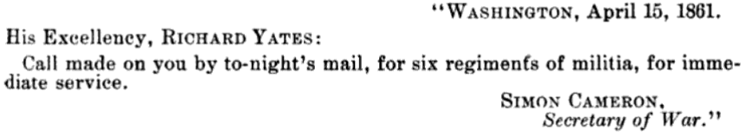
“Let us forget the matter as soon as possible.” This was the sound advice given by Rev. A.J. Joslyn, the abolitionist editor of the Elgin Gazette and Ed Joslyn’s brother, in the days after the violent clash between the would-be soldiers from Elgin and the aspiring warriors from Geneva. The cause of the War at Home was muskets or rather the lack of the same.
Patriotism was running high when a group of Elgin luminaries, many members of the Elgin Washington Continental Militia, assembled at Elgin’s Davidson’s Hall on the evening of 19 April 1861. Even before the meeting and “…immediately upon knowledge of the President's call. Sergeant (afterward Captain) George F. Wheeler went before the Elgin city clerk and took an oath of enlistment on the morning of April 16th and has always strenuously insisted that he was the first man to enlist in the State of Illinois. Who can deny his patriotic claim !”

Fort Sumter had been fired upon on 12 April 1861. On 15 April 1861, President Lincoln (just inaugurated on 4 March 1861) called for seventy-five thousand volunteers for ninety-day service in defense of the Union. Within days of that call-to-arms, the Elgin Continentals would be riding the “cars” on their way to Camp Yates just west of Springfield, Illinois. They had barely missed General Swift’s first train to Cairo from Chicago, probably because of John King’s delaying action.
Lieut. Orlando Davidson moved that “Col.” Bixby Elias Dodson assume the chair at Davidson’s Hall. The good doctor did have some military experience. For eight months in 1835, he had been a private in Captain Edwin Vose “Bull” Sumner’s Company B of the legendary First U.S. Dragoons. B. E. Dodson served at Fort DesMoines and then on an expedition to a Sioux treaty session in Winona on the Upper Mississippi. The U.S. First Dragoons were created after the 1832 Black Hawk War proved that the poorly disciplined Illinois Militia Rangers were not up to the task of dealing with the Sioux, Fox, and Sac tribes. Ironically, in that same year of 1835, B.E. Dodson’s older brother C.B. Dodson held the contract for transporting the Fox Valley Prairie Pottawatomie to their coerced and assigned new “home” in the Council Bluffs area of Iowa.
After Rev. N. C. Clark opened the Davidson Hall meeting with a prayer, “Colonel” B.E. Dodson gave an “appropriate and patriotic speech.” John S. Wilcox, Esq., another Elgin attorney, and later prominent Kane County historian, along with Orlando Davidson and G.W. Renwick, drafted a resolution stating the purpose of the meeting. Letters were read, including one from Gen. Elijah Wilcox, father of John. Capt. Edward S. Joslyn was in Naperville that evening and was unable to attend, but he telegraphically urged those present, “Go on; I am with you for the defense of our country.”
A brass band played and then Reverend/Gazette Editor A. J. Joslyn addressed the meeting. Several other speakers followed. Seventy-Five volunteers, the allowed quota, were enrolled that night. B. E. Dodson as chairman, signed the minutes under the quotation, “The Union must and shall be preserved.” A similar meeting was held at Galena, about 110 miles NW of Elgin, on 16 April 1861, under the chairmanship of Ulysses S. Grant. "Earnest and eloquent appeals" were made by E. B. Washburne and John A. Rawlins. Among Grant’s first assignments after he had weedled, with Washburn’s help, a commission from Gov. Yates was to assume authority for and make an inventory of the State’s meagre Arsenal in Spingfield. Grant thus reprised the 1831 role of Geneva’s James B. Campbell. The Elgin men were “Ho for the War,” but they lacked weapons. This logistics problem was not new in Illinois.
Even before Statehood was granted in 1818, the Illinois Territory had a militia. Elijah C. Berry was the second man to hold the position of Adjutant General of the Illinois State Militia. His son James was the third. Between them, they occupied the position from 1821 until 1839. E. Berry was also the Territorial Auditor, and he retained that position after Statehood until 1831. Berry was a busy man. He had been the Kentucky State Printer before coming to Illinois. In Kaskaskia, he was the owner and editor of The Illinois Intelligencer, which he acquired from Daniel Pope Cook, for whom Cook County was named. Berry was elected President of the ill-fated Illinois State Bank in 1827. His son James and brother William were associates, but he needed more help.
Two men for whom streets are named in Geneva, Major James Blackstone Campbell and Colonel Richard J. Hamilton, received their military titles in the Illinois Militia through their associations with E.J. Berry. In the mid-1820’s Major Campbell from Maury County, Tennessee, was a clerk in Berry’s Vandalia State Auditor’s office. Col. Hamilton of Kentucky was the Cashier of Berry’s Brownsville Branch of the Illinois State Bank.
When Black Hawk crossed the Mississippi in 1831 to return to his village of Saukenuk and his ancestral lands near Rock Island, Governor Reynolds called out 1500 Illinois Militiamen to provide the U.S. Army with a mounted force. Black Hawk was induced to re-cross the Mississippi peacefully that year. His next year’s crossing, however, ended in tragedy. In 1831 notice was taken that, while large numbers of men rallied to the Governor’s call to Alton, many arrived without a weapon. Major James Campbell spent the winter and spring of 1831-2 auditing, cataloging, and gathering up the State’s weaponry.
However, by 1861 Illinois’ arms, still mostly ancient muzzle-loading muskets from the Black Hawk era, were again in scattered disarray. Chicago bookshop owner Augustus H. Burley, chairman of a hastily assembled committee of local patriots, described the arms situation 35 miles east of the Fox Valley in Chicago on 19 April 1861: “The war-committee borrowed from a Milwaukee company fifty muskets, but the force was largely armed with squirrel-rifles, shotguns, single-barreled pistols, antique revolvers, and anything that looked as if it would shoot, that could be obtained from the gun stores, second-hand and pawnshops.”,
The nearest Federal stockpile of about 36,000 rifles and muskets was warehoused at the St. Louis Arsenal, and the secessionists were active there. Captain Nathaniel Lyon of the 2nd Infantry, U.S. Army, during the evening of 29 April 1861, on orders from Secretary Cameron, transported 21,000 rifles and muskets to Alton, Illinois via steamer. Lyon took a series of actions almost on his own initiative to confront the secessionist Governor Claiborne Jackson and maintain Union control of St. Louis and much of the State of Missouri. In August Lyon was killed at Wilson’s Creek and soon after Geneva’s 52nd Illinois Infantry recruiting camp was named “Camp Lyon.”
On the evening of April 15, 1861, Governor Yates received a message from Simon Cameron, Secretary of War, calling for six regiments for immediate service. Illinois Adjutant General Thomas S. Mather, the following day, issued Governor Yates's proclamation calling into service six regiments of state militia. When the requisition was made, the military force of Illinois existed mostly on paper. There were neither brigades, regiments, nor battalions. There were hardly thirty militia companies in the entire state, and they were mainly located in the cities, where drill was occasionally held only “for exercise and amusement.” Such was the state of preparedness in Illinois when the call to arms was received.
Lacking both arms and men to carry them, Yates called the legislature into emergency session. The legislature appropriated $3 million immediately and further resolved: “That the faith, credit, and resources of the State of Illinois both of men and money, are pledged, to any amount and to every extent which the Federal Government may demand.”,
If any doubt exists over the crucial nature of possession of arms, a doubter might consider this communication from Lyon to Yates:
“SAINT LOUIS ARSENAL, April 16, 1861.
Captain Lyon, Second Infantry, commanding the troops at Saint Louis Arsenal, would respectfully submit to his Excellency Richard Yates, governor of Illinois, that in view of imminent danger of an attack at this point by the secessionists upon this arsenal, the custom-house, treasury, and post-office in Saint Louis, it would be well to communicate with the authorities in Washington for the purpose of holding the six regiments called for from his State in readiness for service here. At Jefferson Barracks, ten miles below, quarters for three thousand men could be had, and some one thousand or two thousand could be quartered here. A sufficient excuse also exists in the fact that the four regiments called for from this State cannot be had. As the arms of this arsenal are the main object of attack here, it might be well for Governor Yates to make requisition, for a large supply of arms, and get them shipped from here to Springfield.
N. LYON,
Captain,
Second Infantry, Commanding.”

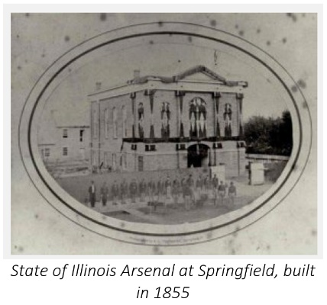
As drawn from the account of Rev. A.J. Joslyn, the facts of the Elgin versus Geneva “War at Home” seemed to be these: “…as nearly as they can be ascertained under the present excitement.” Under the orders of Illinois Militia General R.K. Swift from Chicago, some 90 muskets were brought from Lodi Station to Geneva, where John King, Esq., was in the process of recruiting an independent company of 90-day volunteers.
How King persuaded the “Lodi boys” to surrender their muskets is unknown. On 19 April 1861, Governor Yates had directed General R.K. Swift in Chicago to “arm and equip as quickly as possible as strong a force as he could raise…ready to march at a moment’s warning.” The need was especially urgent as Confederates seemed to massing for an attempt to take Cairo, strategically located on the Ohio River near its confluence with the Mississippi. The “War at Home” was the first skirmish of what would become known as “The Military Expedition from Chicago to Cairo.”
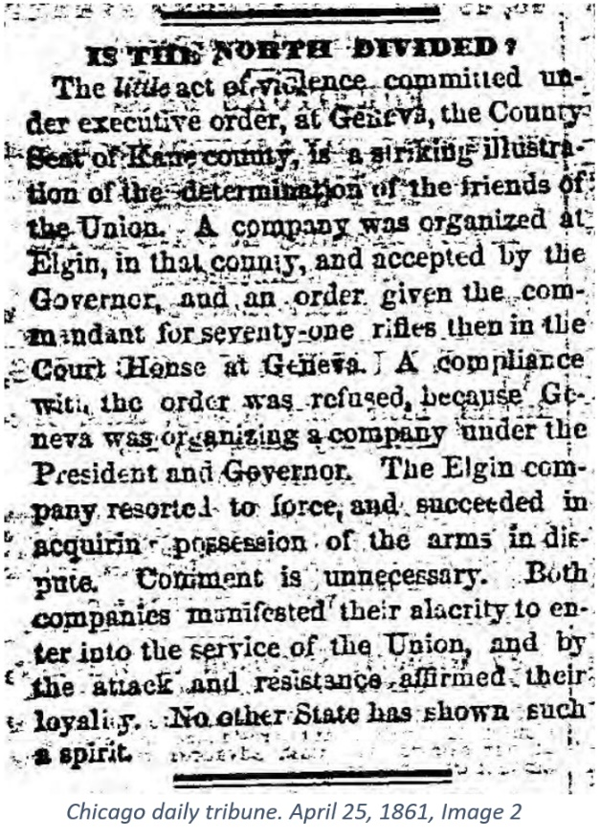
A couple days later, somehow informed of the presence of the weapons at Geneva, Captain Edward S. Joslyn bypassed General Swift. Joslyn telegraphed Adjutant General Thomas S. Mather of the Illinois Militia in Springfield, requesting that Mather direct Kane County Sheriff Demarcus Clark to provide Joslyn with the Geneva “rifles.”, Edwin Joslyn, like John King, was an Elgin attorney and had many ways to know what was happening in the county seat.
Quarter Master General John Wood replied, “You are authorized to receive from Sheriff [Elgin’s Demarcus Clark] the rifles…” Here is how Rev. Joslyn finished the story:
“Capt. Joslyn sent an order to Geneva on Tuesday [23 April 1861] for the guns; in the evening word came that the guns were refused. The Captain detailed a number of picked men and proceeded with them to Geneva. Sheriff Clark was called and the order shown him, and he ordered the guns delivered, but King with some 20 resolute men were with them [i.e., the guns] in the grand jury room, all armed with clubs, stones, and bars of iron, and threatened to kill every man who attempted to enter. The Continentals stove in a panel of the door and rushed through one by one, receiving heavy blows from those within. A conflict of two minutes gave the Elgin boys possession of the room and the guns, but several of them were seriously injured. As they came into town on Wednesday morning covered with blood the excitement was intense. S. G. Ward received a terrible gash on the head with a bar of iron [some saw it as a fireplace poker] and a severe blow on his left arm; Ryan, who is 6 feet six, is terribly cut up; and the Captain [Joslyn] received some injuries in the breast from stones. The injured were put under the care of our surgeons [presumably including Dr. Dodson], and their departure of the company, which was set for 9 AM was postponed until 2 PM.
We deeply regret the collision. Our company felt certain that they were right, and we suppose that the Geneva boys were sure they had a right to the guns. We should have supposed that Mr. King knew the captain of this company too well to resist his effort to take the guns. He is not a man to be balked in his plans. We hope that the other party is not so badly injured as the one here, but we fear that our old friend King is badly used up. Let us forget the matter as soon as possible.
P. S. Since writing the above we learned that a meeting was called for last night at the courthouse and that Geneva is in a blaze of excitement. We understand that many attach blame to Sheriff Clark, because he did not restrain the Continentals. We assure our friends in Geneva that Mr. Clark nor no other man could have controlled the men who were there. Sheriff Clark and his deputy are wholly innocent in this matter – let Geneva forbear until explanations can be made; there should be no strife between us for we are brothers.”
The above description of the affray at Geneva appeared in column 5 of page 1 of the Elgin Gazette of 25 April 1861. In column 6 was a synopsis of Captain Abner Doubleday’s report on the attack on “Fort Sumpter” [sic] that had occurred on 11 April 1861. Also, in the same issue was a statement inserted by a group from Wayne Township in DuPage County stating that Democrats and Republicans were joining together. However, they also sought to quell rumors that Republicans planned lynchings of Anti-War Democrats.
A more hopeful note under the immediate circumstances was the news on page 3 that the Continentals had received 20 rifles on loan from the company that was being formed in Wheaton. Finally, the legal firm of E.S. Joslyn and J.S. Riddle announced its dissolution. Captain Joslyn had made a sudden career change. Not long after, John S. Riddle was a company Captain in the 127th Illinois Regiment. Captain Riddle, who was a staunch Democrat before the War, died of his Vicksburg wounds in July 1863.
The Kane County Advertiser took up the Geneva cause in the “collision” that occurred on the evening of 23 April 1861. John Wilson, the half-brother of Benjamin Wilson, was the editor in 1861. The paper had been owned by Benjamin Wilson and Joseph Cockcroft. A meeting was held in Geneva where resolutions were passed condemning the actions of the Elgin Continentals. This gathering was labeled “The Indignation Meeting” by the Elginites. The Advertiser published the resolutions, but these are lost to history.
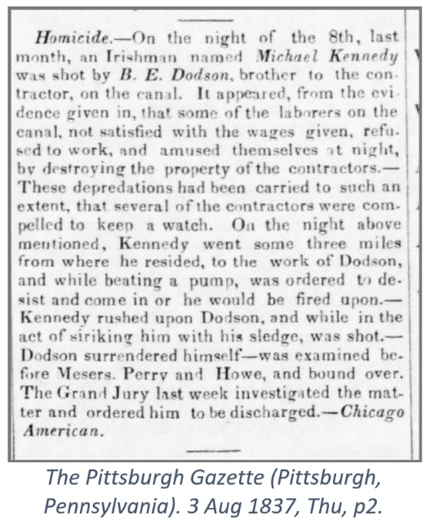
Only the scathing Elgin Gazette rebuttal by Bixby Elias Dodson directed to Advertiser Editor John Wilson’s defense of Geneva seems to have survived. One can suppose that Wilson had advanced the age-old proposition that possession is nine-tenths of the law and cited King’s authorization from Gen. R. K. Swift that was by-passed by Joslyn outside the chain of command.
Then the fluid situation must be considered. Fort Sumter fell on 14 April 1865. Lincoln called for 75,000 volunteers the next day. On 19 April, Gov. Yates called upon Chicago for troops, and three days later, a detachment of 450 men under the command of Gen. R.K. Swift was on duty in Cairo. These were the first Illinois troops to reach the front. Rev. Joslyn knew that John King had been in contact with General Swift and that King had invoked Swift’s authority when he “refused” Captain Edward Joslyn’s demand.
The Pittsburgh Gazette (Pittsburgh, Pennsylvania). 3 Aug 1837, Thu, p2.
Dr. Dodson’s letter was written on 26 April 1861 and is given here in its entirety.
“Elgin Weekly Gazette, 5-2-1861
“WAR AT HOME!”
Mr. Editor:
I have read with mingled feelings of mirth and astonishment the sensation articles in that wonderful paper, The Kane County Advertiser of 25 April, which devotes nearly two columns editorial – indignant &c., to the ‘war at home.’ I would ask you to republish those articles in your paper, that the people of Elgin might see their tone, but for the fact that I know you would not be willing to pollute your paper with such trash and falsehoods. Now, the whole burden of the song of Genevians [sic] is a mere tissue of falsehoods from beginning to end. They begin, in the editorial, by stating that
“Captain King said that he would not give them up, (the arms), only on proper authority;’ then follows their tirade of abuse and falsehoods against Captain Joslyn, and in vindication of King, that makes the cheek tinge with shame for his countrymen. Why did they not tell the truth, and say they were holding the arms, under no pretended authority of or from the State? Why do they venture to so contumaciously abuse and falsify Captain Joslyn? The answer to this is plain; they knew he was gone to defend his country, and therefore he could not attend to them in person or that editor would not have penned that article or those resolutions, (they minded to not say who proposed those resolutions), would have never passed.
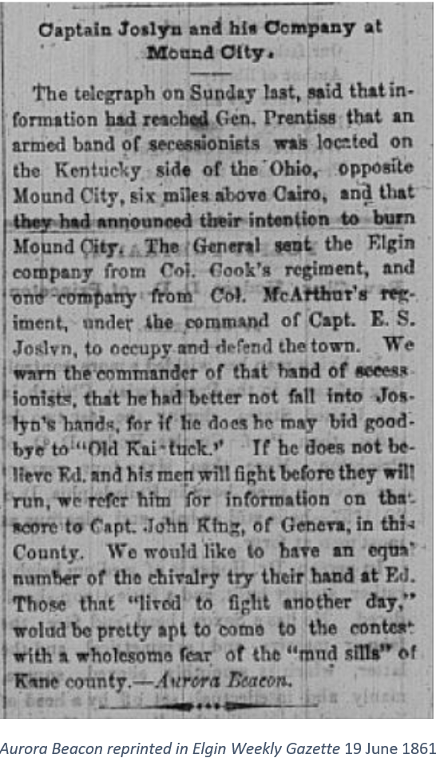
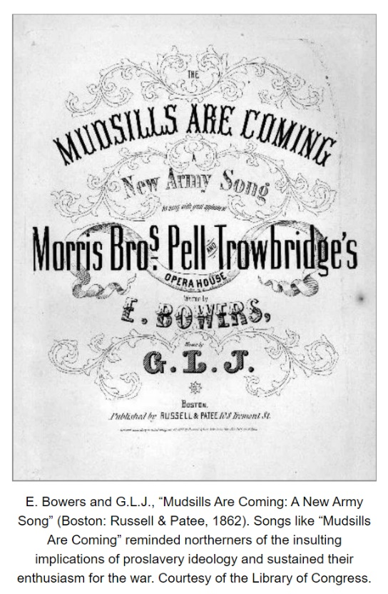
I was heartily sorry to see my friend James’ name attached to those resolutions. Now, a brief synopsis of the facts in that unfortunate affair will satisfy my Geneva friends that they have been very foolish in their premises. What are those facts? Mr. King took pains and trouble, in a commendable way, to get the arms for the Geneva boys and himself – they were in his hands and subject to the order of the Government or the Lodi boys. When Captain Joslyn had his company full and had received orders to march, finding that those arms were at Geneva, and knowing that King’s company was not accepted, he telegraphed to Springfield and obtained the order for the guns published last week. When this order was received, Capt. Joslyn selected Charles Harvey, a son of one of our oldest and most respectable citizens, a member of the Board of Supervisors, and young Mr. Harvey has resided at Geneva and is well known there as a young man of truth and veracity and good moral character – Capt. Joslyn sent him with the order from the Adjt. General and the Sheriff’s order, to which Mr. King replied, he ‘should not give up the guns.’ Mr. Harvey went to the office and telegraphed Capt. Joslyn the answer. Joslyn replied to remain, and he would come and take the guns; but Harvey getting no reply, (the operator at Geneva refusing to give it to Mr. Harvey, but gave it to Mr. King, hence King’s preparation to meet the boys.) Captain Joslyn selected 20 (not 45, as stated in the Geneva paper) of his boys, went down, got the Sheriff, showed him a certified copy of the Elgin telegraph operator, of the Q. Master’s order, the Sheriff went to the quarters of Lord King, told him the order was supreme and must be obeyed, to which King replied he would open the door for no one until his friends had seen the order and advised his compliance, and that anyone attempting to enter, did so at his peril. Here is a moment when cool council might have prevailed, for had Mr. C. Patten, A. Harrington, C. B. Dodson, Judge Wilson, Mr. Nelson or any other Genevian of sense been there and told the bull-head to have opened the door he would probably have done it, but remember Capt. Joslyn was in no mood for parley or delay – he had agreed to march at 9 o’clock next morning, he considered the obstinacy of King had deprived him of spending his last night at home! Perhaps for all time to come, with his wife, children and friends, and he did just what you might have expected Capt. Joslyn to do, viz., stormed the battery; and what did he find? He found King with as many men as he had, armed with clubs, iron pokers, and not balls, but a bushel of stones suitable for throwing. The rest you know – it took about two minutes for the surrender of “the King’s arms.” Capt. Joslyn and every man that was with him at Geneva, with the arms, are today mustered into regular service, and are in the field ready to do duty for their, our and your country, and had there been any of the spirit of ’76 or magnanimity in the heart of Capt. King he would, the moment he knew that Joslyn was ready to go to the field and he was not, he would have said yes, sir; here are the arms, use them well for your country’s defense. I have been at trouble and expense to get them and fit them for my company, but our country first and personal feelings second – I will trust the State to furnish me with others.
B. E. Dodson [M.D.]
Elgin, 26 April 1861”
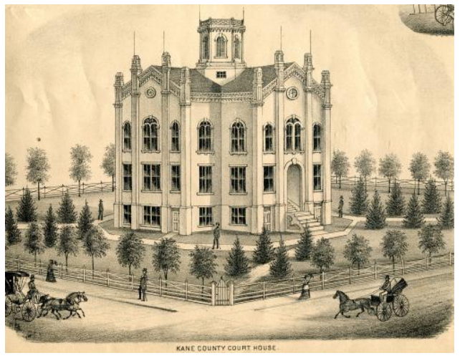
The following week in the Gazette of 9 May 1861, Dr. Dodson apologized for his accusation of duplicity on the part of Mr. June, the telegraph operator in Geneva: “I thought I had ample proof of the correctness of the assertion, but I find on full investigation that Capt. Joslyn’s reply to Harvey did not arrive prior to Harvey’s last call for the answer, I, therefore, take great pleasure in exonerating Mr. June, the operator at Geneva, from any blame in the matter.”
Dr. Dodson, of all the actors in the “War at Home” drama, should have been more sympathetic to the losers. B.E. Dodson was no stranger to vigilantism, having shot and killed an Irish canal worker named Michael Kennedy during an incident that had only one surviving witness. And Dodson had been a medical student at the Franklin Institute in St. Charles in the spring session of 1849 during the “Richards Riot.”
Dr. Dodson graduated from the Rock Island School of Medicine following the fall 1849 session. To become a graduate, attendance (and paid tuition) was required at two 16 week courses of lectures. The fall 1849 lecture course was the only one ever given at the Rock Island institution. One of Dodson’s Rock Island fellow graduates was Obed Harvey. Obed was the son of David Harvey , and Obed was Charles M. Harvey’s (aka “Gazetteer” – see below) first cousin.
Obed Harvey’s medical preceptor was Dr. George Washington Richards of St. Charles. Richards was also the Professor of Anatomy there. Later, Richards was a founder and the Professor of Theory and Practice in Rock Island.
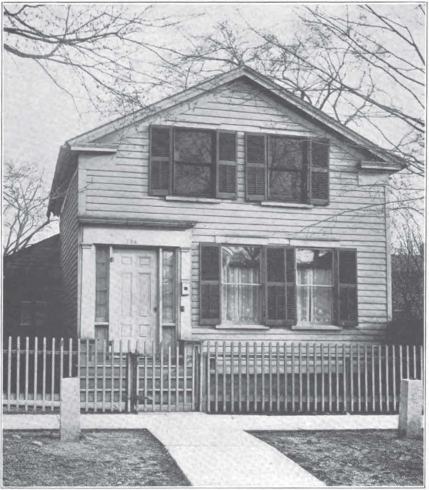
In the spring of 1849, Richard’s medical school, The Franklin Institute, was located in St. Charles, IL. That was when an armed mob from Sycamore confronted him and some of his students on the front porch of his little 1 ½ story Greek Revival home on South 5th Avenue in St. Charles. This was an altogether different kind of property dispute.
The body of Marilla Kenyon, the deceased wife and daughter of a prominent DeKalb County farmers, disappeared from her grave in the Ohio Grove Cemetery in Cortland Township. A Franklin medical student, John Rood of Lodi, was killed by a bullet that went through the door. Richards was shot in the right hand and right upper chest, damaging his right brachial plexus resulting in a severe and permanent right arm palsy. His dissection days were over, and he had to learn to write left-handed. Obed Harvey was a student at the Franklin Institute in the spring of 1849, as was Bixby E. Dodson. George Bunker, Obed Harvey, and Dodson all followed Dr. Richards to Rock Island in the fall of 1849 to complete their medical educations.
Dr. Richards referred to "Harvey" in a letter written from St. Charles to George Bunker of in October of 1848. The suspicion exists that George Bunker and Obed Harvey were the second and third members of the resurrection team that raided the Cortland Township Ohio Grove Cemetery near Lodi. This letter included, “As there is much I want to see you and Harvey about and many things oncoming of some importance to us all, I must request you to come out as soon as you receive this and bring Harvey with you. Don't disappoint me.” In 1851 Dr. Bunker, then practicing in Kaneville, IL, received a letter from one of his former medical acquaintances, Dr. Willis Danforth, inquiring about anatomic “material” and soliciting Bunker’s help in acquiring same.
Dr. Richard’s two daughters each married one of his students. Juliette Richards (1828-1858) married Robert Innocence Thomas in 1845. Mary Jane Richards (1830-1908) married Orpheus Everts. Thomas began a medical practice in Geneva and Evert’s did the same in St. Charles. Both left soon after and returned to LaPorte IN where they began a short lived newspaper partnership.
After Thomas left to join Dr. Richards in practice in Dubuque IA in about 1851, Everts continued a Democratic newspaper in Laporte IN. Thomas, a Republican, began sheet in Dubuque IA. The two became estranged. Both served in the Civil War as surgeons.
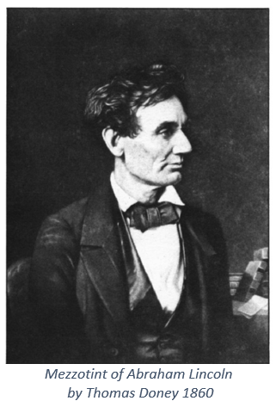
Dr. Dodson was active as a letter writer while in Elgin. For example, he had written to Abraham Lincoln in Springfield sometime in July of 1860. His letter has not been found, but Lincoln referred to it in his own missive to Thomas Doney of Elgin dated 30 July 1860. Doney was an Elgin artist and engraver who gifted a mezzotint portrait of Lincoln to him. Lincoln wrote Doney:
“The picture (I know not the artistic designation) was duly and thankfully received. I consider it a very excellent one; though, truth to say, I am a very indifferent judge. The receipt of it should have been acknowledged long ago; but it had passed from my mind to reminded of it by the letter of our friend, Dr. Dodson.”
Dodson was not the only Gazette correspondent. Under the title “Geneva,” Editor Joslyn reported that he had received from a “young man belonging to one of the oldest and most influential families in Geneva… a communication touching the ‘indignation meeting’ held in that place, from which we make the following extract.”
“Your correspondent cannot but remember that when said meeting was in session Capt. Joslyn and his brave compatriots had left their homes, however humble, yet honorable and happy, their wives, children and kindred at their country’s call, but her flag had been humbled, and offering in her defense their services…” Now true patriotism would have bid them “Godspeed” – would have dried up the sorrowing tears of those, perhaps to be widowed, wives and orphan children left behind.
Whilst your correspondent wishes no harm to the participators in said meeting, yet could they remembering former friendships and kindnesses, have seen the pale faced wife and mother of Capt. Joslyn’s flaxen haired boys enter the People’s courthouse and have heard that wife ask in trembling accents, who is it that to slander my husband and the father of my boys? Don’t you think the handwriting would’ve been seen upon the wall? It is to be hoped that the wrongs inflicted will be speedily repaired.
Your correspondent has no desire to attribute wrong motives to the persons who were the leading spirits and said meeting, for if they are satisfied with the record they have made, let them defend it.
The brave band of Continentals, the flower of your city, and such is the hope of our country, may they in sickness and in battle, survive all, and with well-earned honors, return to their homes to face those who found it safer to defame in their absence, then in their presence, in the hope is the hope and prayer of …Gazetteer.”
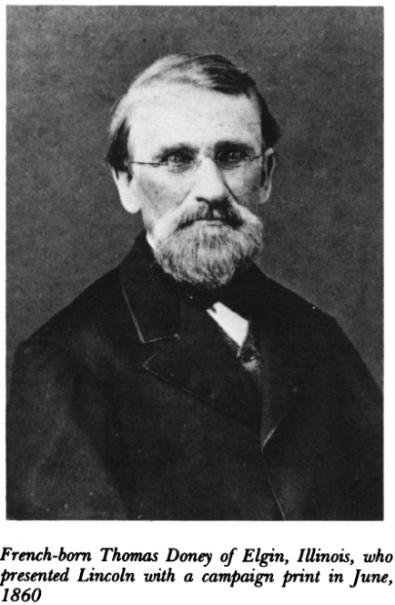
“Gazeteer” apparently did not name the “leading spirits” of Geneva’s “Indignation Meeting.” The reader is also left to speculate just who “Gazetteer,” the Geneva son-turned-defender of Elgin, was. Charles M. Harvey seems to have been a trusted member of Captain Edward Joslyn’s inner circle. And Charles Harvey had family ties to Geneva. In fact, in the 1860 U.S. Census, Charles was living in the Geneva household of Paul R. Wright, who had come to Elgin in 1837. In 1856 Paul Wright was the Frémont Ticket candidate for Kane County Clerk and Recorder. After he won, Wright moved to Geneva.
Paul Wright had “read” law in the Elgin law office of Captain Edward E. Harvey starting in 1844. He was admitted to the bar in 1845 and began practicing in Elgin. Prior to that, at the age of twenty-one, Edward E. Harvey had read law in the office of Joseph Churchill of Batavia and then became the first lawyer in Elgin. Joseph Churchill married a daughter of “Daddy” Isaac Wilson, Judge Isaac Wilson’s sister. Regional interconnections, both professional and familial, abounded in the first decades of Geneva’s existence.
An adage holds that when a town gets its first lawyer, he starves. But when a second attorney arrives, they both make a nice living. Sometimes, though, professional relationships broke down, and grudges developed. For example, Joseph Churchill and Isaac G. Wilson were said to have been estranged for years after being opposing lawyers in an action where one questioned the veracity of the other. Yet Joseph was married to Isaac’s sister.
Charles Harvey was listed as a clerk in the 1860 census. He was working for his Uncle Paul R. Wright. Listed on the same census page a few lines down was Charles’ grandmother Polly Bennett Harvey, the widow of Joel D. Harvey, Jr., who came to Kane County in 1835 where his father, a blacksmith by trade and also named Joel, had a 320-acre claim in what is now northern St. Charles Township. Joel, Sr., died in 1837, and Joel, Jr. died in 1840. Also on nearby Geneva Census pages were listed John Patten, William Larrabee, Eben Conant, and Attorney William Plato.
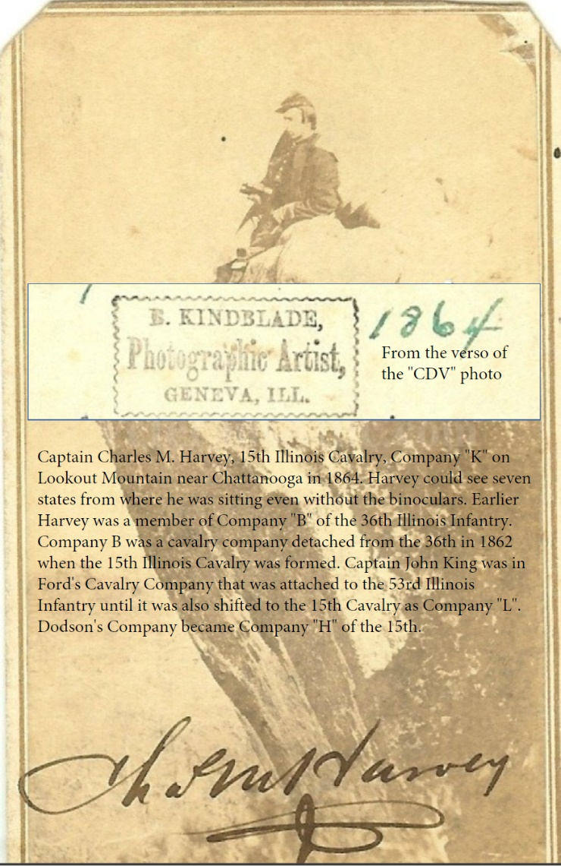
The third Joel Harvey, later of Geneva (Fabyan Villa was the Joel Harvey home) had married Julia Plato, daughter of William Byron Plato, in Geneva in October 1858 and was living and practicing law in Aurora in 1860.
William Plato, who came to the Fox Valley in 1837, was one of the electors on the Frémont Presidential Ticket in 1856 and also was an elector for the Lincoln and Hamlin Ticket in 1860. Plato served several terms in the Illinois Senate. Even Carl Sandburg knew of the Plato family. “When William Plato of Kane County came to his [Lincoln’s Springfield] office with the little girl, Ella, he [Lincoln] stood Ella on a chair and told her, ‘and you’re not as tall as I am, even now.’”
Early Geneva property records show Charles Mather, James Brown, Joel Harvey, and Samuel Sterling constructed a two-story tavern house on the southwest comer of State and First. James Brown first came to Geneva with Daniel Shaw Haight in 1833 or 34. The tavern partners overcame shaky finances and problems with their contractors (the Harkins brothers). Housing offices, a saloon, billiard tables, and a dining room on the first floor, with a dancing/meeting hall above, “Geneva House” was a Geneva institution until it burned in 1872. The infamous April 1861 “Indignation Meeting” over the “War at Home” may have taken place at the venerable tavern house, though A.J. Joslyn named the new 1857 Kane County Courthouse as the site. The original Geneva House owners were in the first wave of Geneva’s settlers.
So, was Charles M. Harvey A.J. Joslyn’s “Gazetteer”? Probably—he was only twenty years old at the time, but he may have had help from his Uncle Paul Wright. One suspects the pair may have communicated word of the arrival of the muskets in Geneva to friends in Elgin. In fact, that suspicion is strong since Edward Joslyn, like Paul Wright, was an Elgin Frémont Democrat.

The relationship between John King and Edward S. Joslyn, rival Elgin attorneys, may have soured long before the fateful Geneva evening of 23 April 1861. Edward Joslyn, a Democrat, was not an abolitionist. However, he was not a Copperhead Democrat who favored Southern secession. Edward and his older brother A.J. publicly butted heads over the slavery issue, often speaking as opponents in public debates. Editor A.J. Joslyn referred to “our old friend King” in the same sentence that he advised that the “War at Home” be forgotten. A.J. Joslyn and John King were like-minded on the slavery issue.

Edward Joslyn had owned the Elgin Gazette for a time in the 1850s, but by the summer of 1860, the paper was a Republican organ under the editorship of A.J. Joslyn.

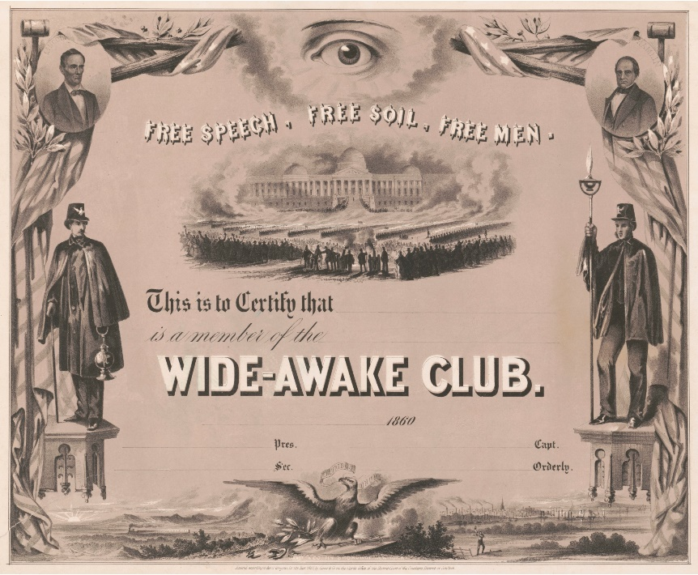
In that summer of 1860, the Gazette reported on a Republican meeting at Clintonville, now the City of South Elgin. “Charley Wells” of Geneva was to have been the keynote speaker at Clintonville, but he could not make it. Dr. B.E. Dodson substituted for him, and Joslyn opined "His [Wells’] place was well filled however, if any man in Kane County can fill Charley Wells place, by Dr. Dodson, of Elgin, who made a solid and convincing speech of about an hour's length, showing up the popular sovereignty humbug, and exposing the quibbles to which its exponents are obliged to resort.”
“After a song by the Wide Awakes John King Esq. was called upon and made a brief effectual response, frequently interrupted by the applause of the audience… Another song was demanded from the Wide Awakes, after which A. A. Keyes was called for, and responded in a short address in behalf of "Young America.”
“The War at Home” in the spring of 1861 had a back story of Elgin political conflict. Somehow John King, Esq. and B.E. Dodson, M.D. were Wide Awake Republican comrades in 1860 but already adversaries in 1861.
John King had been advertising his legal skills in Elgin since at least April of 1858. The 1859-60 Kane County Directory listed his law office in the Union Hall Block of Mill street. King was also the proprietor of the Elgin Circulating Library of 800 volumes housed at his office. On 19 June 1860, the U.S. Census for Elgin, Kane County, listed John King, 42, as having been born in Massachusetts in about 1816 and married to Ruth J. Battles, 25, who was born in Maine in 1835. Three-year-old John Reginald King, born in Maine, rounded out the King household.

The Official Record as Reported by General R.K. Swift

General Swift made his official report on the events that surrounded The War at Home on 15 May 1861 by writing to Governor Yates. Swift began by quoting a message from Yates:

“At 5 o'clock P. M., of the 19th ult., I received your order by telegraph, a copy of which is as follows:
SPRINGFIELD, April 19, 1961.
GENERAL SWIFT:
As quick as possible have as strong a force as you can raise armed and equipped with ammunition and accouterments, and a company of artillery, ready to march at a moment's warning. A messenger will start for Chicago tonight,
( Signed ) RICHARD YATES, Commander-in-Chief.”
Editor A.J. Joslyn acknowledged that John King had been in communication with General Swift. However, probably unknown to King, Swift had a far stronger connection with Edward Joslyn and the Elgin Continentals through Lincoln’s “intimate friend” and law student Major Elmer Ellsworth who had drilled them. “By December 1857, he was being addressed as Major Ellsworth, for that devoted friend General R. K. Swift, whom he had affectionately described as ‘bluff, hearty, and good-natured,’ had appointed him an aide on his staff [Illinois Militia, now Illinois National Guard] with this rank.”
Swift continued in his Report: “Upon receipt of these orders, I redoubled my efforts, and sent orders by telegram to military corps in my brigade at Lockport, Joliet, Plainfield, Elgin, and Ottawa, for the immediate movement of all troops to Chicago holding serviceable arms.” Note the absence of Geneva from this list and the presence of the phrase “holding serviceable arms.” This was probably the telegram that Ed Joslyn presented to John King.
General Swift also reported that he arrived at Cairo to defend it, “notwithstanding we had only a short supply of percussion caps.” The first time during their defense of Cairo that the Elgin lads heard “the long drum roll” signaling an attack, they grabbed their muskets and formed ranks but had no ammunition for John King’s muskets. Fortunately, it was a false alarm.
Geneva had another connection with the outcome of “The War at Home.” The Paymaster of Swift’s expedition to Cairo, Illinois, was Chicagoan Joseph Dana Webster. Webster had many associations with Swift. Webster was also Eben Danford’s partner in Geneva’s Danford Reaper enterprise. Webster was the Colonel of Swift’s First Illinois Light Artillery.

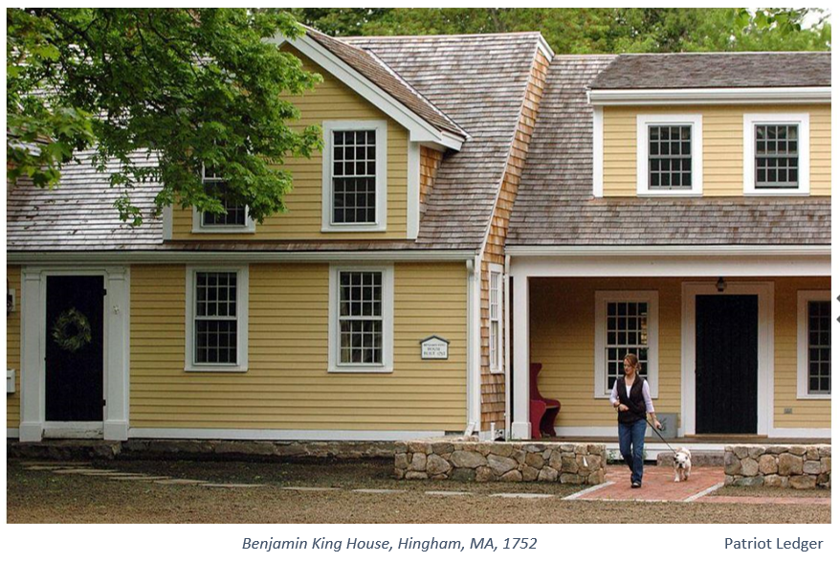

http://saopublic.co.kane.il.us/Pages/History.aspx
Joslyn, R.W., and F.W. Joslyn. History of Kane County, Ill. Pioneer Publishing Company, 1908. vol. I, p820. https://books.google.com/books?id=h0BEAQAAMAAJ Geneva was actually then located in Sandusky Precinct. Kane County had been carved from LaSalle in 1836 but townships were not established until the Illinois Constitution of 1848 authorized them.
The Fredonia [NY] Censor, 15 December 1824.
Carr, E.I. The History of Rockton, Winnebago County, Illinois, 1820 to 1898. Herald Office Print, 1898. p72.
“Hoosier” was variously defined on the frontier. Often enough “Hoosier” was a term of derision, i.e., an sort of ethnic slur. Graf, J. “The Word Hoosier.” Indiana University, Bloomington, 2016. https://web.archive.org/web/20180312231908/http://www.indiana.edu/~librcsd/internet/extra/hoosier.html [5/21/2019]
Peirce, Henry B., Arthur Merrill, William Henry Perrin, and Le Baron W. Jr. The Past and Present of Kane County, Illinois, Containing a History of the County ... A Directory. Chicago: W. Le Baron, Jr., & Co., 1878. p315. This passage, probably written by Kane County Clerk Henry Peirce, was likely the source of many amost slanderous Joslyn pronouncements. Dodson, “The worthy informant,” as can be discerned in the 1878 description of his debate with James Herrington, had some quirks of his own.
Doerr, Brian M. “The Massacre at Deer Lick Creek, Madison County, Indiana, 1824.” Indiana Magazine of History 93, no. 1 (1997): 19-47. Accessed May 19, 2020. www.jstor.org/stable/27791980
Bingham, T.A. Genealogy of the Bingham Family in the United States Especially of the State of Connecticut. 1898. p3. https://archive.org/details/genealogyofbingh00bing/page/n13/mode/2up/search/Deacon+Thomas+Bingham
Joslyn, Rudolphus Waite. The Philosophy of Happiness: A Consideration of Normalism. Elgin, Illinois: Normalist Publishing Co., 1910. p543-4.
Joslyn, Rudolphus Waite. Personal Injury Cases, Illinois, Including Cases under Dramshop Act and Assault and Battery; the Law and the Facts Alphabetically Arranged. Chicago, T. H. Flood & co., 1908.
Joslyn, Rudolphus Waite. Twelfth Commandment: Thou Shalt Not Profit by the Labor of Other Men; Being a Report of the Discussions of the Octagon Club. Elgin, Ill.: Normalist Publishing Co., 1919. The Rights of Labor: An Inquiry as to the Relation, Employer and Employed. Unity Library; No. 37. Chicago: Charles H. Kerr & Co., 1894.
Twelfth Commandment, Preface. Sentence structure is generally much better than the inaugural one.
https://www.findagrave.com/memorial/15576120/julius-warren-dodson
Warren, Harriet, “The Warrens of Warrenville” p134. Year: 1850; Census Place: Winfield, Dupage, Illinois; Roll: 105; Page: 53a
US Census — Year: 1850; Census Place: Winfield, Dupage, Illinois; Roll: 105; Page: 53a.
Dodson's Kane County Independent Cavalry Company was organized on 1 Sept 1861. The company was assigned to the 15th Regiment Illinois Volunteer Cavalry as Company H on December 25,1862. Dodson resigned in the fall of 1862. https://en.wikipedia.org/w/index.php?title=Independent_Illinois_Volunteer_Cavalry_Companies&oldid=846926047
Ferslew, 1857, p152.
Humphreys, F., Otis M. Humphrey, Henry Reed Stiles, and Sarah M. Churchill. The Humphreys Family in America. New York: Humphreys, 1883. p302-15 (John Brown); p656 (Welsey Humphrey).
Avalon Project - A Plea for Captain John Brown by Henry David Thoreau; October 30, 1859. [Read to the citizens of Concord, Mass., Sunday Evening, October 30, 1859.]
Only two issues of the Kane County Advertiser are listed in the Chronicling America files of the Library of Congress: 2 April 1857 and 31 July 1862. https://chroniclingamerica.loc.gov/lccn/sn94054362/holdings/ The Advertiser’s lineal descendent, the Geneva Republican, contains a history of Geneva’s newspapers. The charcoaled edges speak volumes about what happened to the Advertiser archives. The issue can be found here: https://box2.nmtvault.com/Geneva/jsp/RcWebImageViewer.jsp?doc_id=951e1468-4019-4052-aa17-f80b54427909/gn000000/20120724/00000183
On Some Forms of Literature by Arthur Schopenhauer, translated by Thomas Bailey Saunders. Wikisource, https://en.wikisource.org/w/index.php?title=On_Some_Forms_of_Literature&oldid=5450875 (accessed June 21, 2020).
Cunliffe, J.W., and G.R. Lomer. Writing of Today: Models of Journalistic Prose. Century Company, 1920. p154. https://books.google.com/books?id=S1lAAAAAYAAJ
De Armond, F. “Thoreau and Schopenhauer: An Imaginary Conversation” The New England Quarterly, Vol. 5, No. 1 (Jan., 1932), pp. 55-64 Published by: The New England Quarterly, Inc. Stable URL: http://www.jstor.com/stable/3594
https://news.harvard.edu/gazette/story/2015/07/uncovering-what-thoreau-uncovered/
“The War at Home” was the name attached to the event described here by Bixby Elias Dodson. Possibly the descriptive title was first penned by Geneva Kane County Advertiser editor John Wilson. Dodson was listed as living on Main Street in Dundee IL in 1859. Kane County Directory, 1859.
Gough, K.L. Col. Edward Swain Joslyn. Elgin Area Civil War Soldiers https://elginareacivilwarsoldiers.blogspot.com/2013/07/lt-col-edward-swain-joslyn.html
Military, Illinois., Naval Department, J.N. Reece, and I.H. Elliott. Report of the Adjutant General of the State of Illinois ...: 7th to 15th Regiment. Phillips Bros., state printers, 1900. p6. https://books.google.com/books?id=fAYTAAAAYAAJ
The Elgin Gazette, vol6, no49, 25 April 1861, p1, col5.
Adoniram Judson “The Elder” Joslyn was a Baptist Minister and the Editor of the Elgin Gazette. He signed the Roll of the Elgin Class II Militia on 7 August 1862 as verified by the signature of Geneva’s Henry B. Peirce as County Clerk (and later important Geneva historian). A.J. Joslyn was the secretary of the meeting in Geneva of abolitionists and “Free Soilers” who created the Republican party in Kane County on 19 Aug 1854. The Republican party was then known as the “anti-Nebraska Party” which favored the preservation of Henry Clay’s Missouri Compromise limiting slavery. Opposing Clay’s compromise was Stephen A. Douglas, whose “Popular Sovereignty” allowed States to decide for themselves the slavery issue via the passage of the Kansas-Nebraska Act. Alft, E. C. Elgin: An American History, 1835-1985. 1st ed. Elgin, Ill.; Crossroads Communications, 1984., p32. A.J. Judson was named for famed Baptist Missionary to Burma Adoniram Judson (1788-1850). Judson College in Elgin is also named in honor of Missionary Judson. A name apparently can be a life guide, as it was for Rev. A.J. Joslyn.
Many of the Elgin men associated with Edward Joslyn’s Company of the Washington Continental Guard had been organizing and drilling for three years under the guidance of Lincoln’s Springfield law student Elmer Ellsworth. Ellsworth was the first Union Soldier to fall in May 1861 at Alexandria VA. Another of Elgin’s early units was known as the “Washington Continental Artillery.” Bateman, vol2, p687. The 1859-60 Kane County Directory listed “E.S. Joslyn, Captain; W.A. Carpenter, 1st Lieut.; J.S. Wilcox, 2d Lieut; S.G. Ward, Orderly Sergeant.” John Wilcox, himself a Kane County historian, was replaced by Lt. Orlando Davidson by the spring of 1861. Ed Joslyn and John Wilcox did not collaborate on much in Elgin or during the War. However, Wilcox does explain the controversy over who is due priority in answering Lincoln’s 90-day call. Wilcox, John S. "Military History of Kane County, Illinois." Journal of the Illinois State Historical Society (1908-1984) 8, no. 3 (1915): 479-86. www.jstor.org/stable/40193812
Kionka, T.K. Key Command: Ulysses S. Grant's District of Cairo. University of Missouri Press, 2006. https://books.google.com/books?id=kqdjoEx_zacC
Dodson, B.E., Military Service (from 23 March 1835 to 4 December 1835); Private in Capt. Sumner's Co., 1st US Dragoons. Sumner was is Harrisburg, PA, from Dec 1834 recruiting men. Tate, T.K. General Edwin Vose Sumner, USA: A Civil War Biography. McFarland, Incorporated, Publishers, 2013. p18-19. The Elgin Gazette bestowed the rank of Colonel on Dr. Dodson, though he had been a private in the U.S. Army. https://books.google.com/books?id=hf8CAQAAQBAJ B.E. Dodson apparently suffered some debilitating event during his service and bills for his “relief” were introduced in Congress by Rep. Orr of Iowa. For example, 42nd Congress, 2nd Session H.R. 1835, Printers No 1511, 4 Mar 1872 directs an “Invalid Pension” be paid of $2418.75 backdated “25 [sic] years 2mo and 10 days from 18 June 1870.” If “35” years were intended, the event would have taken place on or about 8 April 1835. The Bill seems to have been “laid on the table” and never put to a vote.
Letter of Dodson, C.B. to Chicago Historical Society. Geneva, IL, 25 Oct 1879. CHM.
Rev. N.C. Clark preached the first sermon in Kane County in 1835 in the cabin of Christopher Payne on Mahoney Creek just east of Batavia in August 1835. Within a few months Payne sold out to Isaac “Daddy” Wilson, father of Judge Isaac Wilson. The Wilson family occupied the double log cabin for several years. Joslyn, p123.
“War Meeting” Elgin Gazette, 25 April 1861, p1.
Chetlain, Augustus. Recollections of Seventy Years. Galena, Ill., 1899. p69-70.
https://sangamoncountyhistory.org/wp/?p=169 A twelve year old boy started a fire on 19 Feb 1834 that destroyed the Springfield Aresnal which also contained Illinois’ military archives, much to the chagrin of Illinois historians. https://www.cyberdriveillinois.com/publications/illinois_bluebook/chronology.pdf
McMurtrie, Douglas C. (October 1933). Journal of the Illinois Historical Society. 26 (3): 204–208.
Richard Jones Hamilton born August 21, 1799, near Danville, Kentucky; 1820, moved to Jonesboro, Illinois; 1821, appointed cashier of State Bank in Brownsville; 1822, married Diana W. Buckner [cousin of S.B. Buckner, West Point friend of U.S. Grant and, like RJ Hamilton, a Chicago real estate investor in the 1850’s. Buckner unconditionally surrendered Fort Donelson to Grant on 16 Feb 1862] of Jefferson County, Kentucky; March 19, 1824, appointed Gen. Superintendent of muddy saline; January 14, 1826, appointed justice of the peace for Jackson County; March 31, 1827, admitted to the bar; January 29, and 1831, elected first probate judge of Chicago; 1831 – 41, clerk of Circuit Court; 1832 – 37, clerk of Cook County commissioners court; March 25, 1835, married Harriet L. Hubbard at Chicago; 1835 – 37, recorder of deeds for Cook County; 1835, ceased to be probate judge; 1840, alderman of sixth Ward; 1843, married Mrs. Priscilla P. Tooley; 1847, unsuccessful candidate for Colonel of the fifth Regiment for the Mexican war; 1849 – 52, alderman; 1852, presidential electors; 1856, unsuccessful candidate for the lieutenant governor; December 26, 1860, died; in politics he was a Democrat. – Andreas, G. A. T., History of Cook County, Chicago, 1884.
Eby, Cecil. "That Disgraceful Affair", The Black Hawk War. New York: Norton, 1973. p83-86. The lack of an effective mounted force was the impetus for the creation of the First U.S. Dragoon Regiment in 1835.
“An Act Concerning Public Arms” The Revised Laws of Illinois. Vandalia, 1833. p499-501. “Section 5: James B Campbell shall be also entitled to receive out of any money in the treasury not otherwise appropriated, the sum of $150 in full of services and expenses, and those of his assistance during the year 1832, in taking charge of, exchanging, taking and giving receipts for arms at Ottawa, for house rent, and receiving back and making inventories of, and giving acquittances for arms return, etc.; and some to be apportioned under the direction of the governor, to the said James B Campbell, according to the time actually employed and the expenses incurred by said Campbell for house rent and the hire of an assistant, as well as for all services rendered by him as herein specified.”
Pompey, Sherman Lee. Muster Lists of the Drum Corps, Lincoln Illinois Rifles, and the Light Artillery Company on the Cairo Expedition, Illinois During the Civil War. Albany, Or. (725 S.E. Davidson, Albany 97321): S.L. Pompey, 1984.
Burley, A. Harris: The Cairo Expedition. 1892. p4. The Cairo expedition: Illinois first response in the late Civil War--the expedition from Chicago to Cairo. Chicago: Fergus Printing Co. 1892. p4.
McGuire, Randy R., St. Louis Arsenal: Armory of the West. Chicago: Arcadia Publishing, 2001. p95-6.
Located at the intersection of Kaneville Road and State Street. Swadling, J. Historical Memorandum of the Fifty-second Illinois Infantry Volunteers From its Organization, Nov. 19th, 1861, to its Muster Out, By Reason of Expiration of Service, On the 6th Day of July, 1865 (Elgin, IL: Gilbert & Post, 1868); The Chicago Historical Society finding guide for their copy of Historical Memorandum, credits John Swadling, a private and corporal in Company “K” as the author.
Six infantry regiments was exactly the number Illinois sent to the Mexican War of 1846-8. Joslyn and King were each trying to form companies for the 7th Illinois Regiment which was to be Ilinois’ first of the Civil War.
III. Sen. Jour., 22nd G. A., 2 sess., 1861, p57-58. The vote on the issue was unanimous. Yates called the legislature into session on the day he received Cameron’s message. One cannot help but contrast this to Illinois’ response to a pandemic crisis 159 years later when the Governor seized dictatorial powers by Executice Order and the legislature was not convened for months. When it finally met it passed almost nothing.
Dayton, Aretas A. “The Raising of Union Forces in Illinois during the Civil War.” Journal of the Illinois State Historical Society (1908-1984) , Dec., 1941, Vol. 34, No. 4 (Dec., 1941). p401-438 http://www.jstor.com/stable/40189841
OR Ser 1, Vol 1, p667. Arms were shipped to Alton, IL by steamer shortly after this.
Presumably, the village on the C&NW RR just on the Kane side of the DeKalb County line. The name “Lodi Station” was changed to Maple Park in 1880. Callary, Edward. Place Names of Illinois. Urbana: University of Illinois Press, 2009. p205. http://www.loc.gov/catdir/toc/ecip0814/2008012691.html
About 75% of the long guns at the Federal St. Louis Arenal in early 1861 were U.S. Model 1842 altered to percussion, cal .69. manufactured after the Mexican War. The weapons in dispute in Geneva were probably older and came indirectly from the State Arsenal built in 1855. http://www.civilwarstlouis.com/arsenal/index.htm Wilson, M.R. The Business of Civil War: Military Mobilization and the State, 1861-1865. Baltimore: The Johns Hopkins University Press, 2006, p13.
Andreas. History of Chicago from 1857, p270.
Thomas S. Mather. Civil War Union Brevet Brigadier General. Served in the Civil War in the 2nd Illinois Volunteer Artillery, rising to the rank of Colonel. He then served as Chief of Staff to Maj. General John A. McClernand before serving as Acting Assistant Inspector General for the Department of the Susquehanna. He was brevetted Brigadier General, US volunteers on September 28, 1865 for "faithful and meritorious services". He had served as Illinois' state Adjutant General previous to the war (1858 to 1861). https://www.findagrave.com/memorial/7382954
The muskets were probably Model 1816 .69 caliber muzzle loading smooth bore flintlocks that had been converted to percussion cap firing. The Rock Island Arsenal Museum has six types of such altered .69 weapons, four of them being Springfields. None of these had rifled barrels. One Harper’s Ferry .69 model did have a rifled barrel. The Springfields were more prevalent. They fired “buck and ball” (4 buck shot and one larger .69 ball). At ranges up to 200 yards buck and ball muskets were very effective. The rifled Minnie Ball weapons were effective up to 400 yards. https://en.wikipedia.org/wiki/Buck_and_ball Museum, Rock Island Arsenal. Descriptive Catalogue of the Ordnance Museum, Rock Island Arsenal: Rock Island, Illinois. Driffill Printing Company, 1909. p30-31. https://books.google.com/books?id=vxEZAAAAYAAJ
https://www.hsqac.org/quincyan-supplied-cannons-to-union-army-in-1861 John Wood was the Governor of Illinois just preceeding Yates and was among the Quincy Lincolnites that included Orville Hickman Browning. Wood went to Washington to lobby Lincoln for the federal purchase of a light cannon to be produced in Quincy by James Woodruff for the cavalry. Lincoln came uncharacteristicly close to ordering that the cannons be acquired and that the 6th Il Cavalry Regiment be formed to use them. Grierson’s famous raid through Mississippi was comprised of three Cavalry Regiments one of which was the 6th Illinois along with Battery K, 1st Illinois Light Artillery that had six of Woodruff Quincy guns. Descritions of Grieson’s famous raid stated “small pieces made a definite contribution to its success.” http://turnerbrigade.org/history/woodruff/ If only Abe had taken similar interest in Streight’s Raid that was almost simultaneous with Grierson’s.
Gough, K.L. Col. Edward Swain Joslyn, Elgin Area Civil War Soldiers. Samuel G. Ward enlisted in the Continentals as Sgt. in on 22 April 1861 as a 90-day Volunteer. He was a monument maker from New York. He was wounded in the head with a fireplace poker during the Raid on Geneva 23 April 1861. In Company A of the 7th Illinois Volunteer Infantry (Frémont Rifles) as its Captain, he was killed at Shiloh on 6 April 1862 during the withdrawal from the Sunken Road. http://elginareacivilwarsoldiers.blogspot.com/2013/03/capt-samuel-g-ward.html
Gough, K.L. Pvt John Ryan. Elgin Area Civil War Soldiers. Elgin Continentals Enlisted April 22, 1861 Wounded during the Raid on Geneva April 23, 1861. A Co. 7th Ill. Vol. Inf., Frémont Rifles, armed with .69 US Altered musket., Mustered In for 3 months service at Camp Yates in Springfield, IL 25 April 1861.Home of record listed as Elgin, IL. mustered out at Mound City, Il. 25 July 1861. Company I 58th IL Infantry, Pvt. Enlisted – 4 Dec 1861 in Rutland, IL by Capt. Heelan for 3 Years, Mustered In – 34 Dec. 24, 1861 at Camp Douglas, Chicago, IL Remarks - Deserted Feb. 1863 from Camp Butler, Springfield, IL. http://elginareacivilwarsoldiers.blogspot.com/2013/04/pvt-john-ryan.html
Alft, E. C. Elgin: An American History, 1835-1985. 1st ed. Elgin, Ill., Crossroads Communications, 1984.
Scott, F.W., and E.J. James. Newspapers and Periodicals of Illinois, 1814-1879. The author, 1910. p189. Captain J.S. Riddle was wounded at Vicksburg and his left arm was amputated. He died in Elgin from his wounds on 22 July 1863. Elgin Gazette 22 July 1863, p4. His obituary appeared on page 1 of the Gazette, 29 July 1863. https://books.google.com/books?id=LV1KAAAAYAAJ
As so often occurs in a crisis, among the first casualties are civil rights. Yates did not declare martial law and military wannabe’s would not have police powers even if he had. A similar situation after the 1871 Chicago fire killed a prominent former Elginite attorney who, ironically, was the Chicago prosecutor. (vide infra). Both King, who once sold firearms in Maine, and Ed Joslyn, former militiaman, were familiar with firearms. King’s decision to refrain from loading his muskets or even using bayonets showed remarkable restraint.
Tilton, C.C., “Gurdon Saltonstall Hubbard and some of his friends.” Proceedings of the annual meeting, papers presented at that time, contributions to state history. Illinois State Historical Society Transactions,1933. p152.
“friend James” has not been positively identified. However, James Herrington, son of the James Herrington who platted Geneva, was a Democrat and a long-time Illinois State Representative. He was also a Geneva Mayor. Democrats were something of a political anomaly in Geneva at the time. B.E. Dodson was later also a Democrat, serving as a convention delegate for that party in both Iowa and Illinois. Bloomington Weekly Leader, Bloomington, Illinois. 15 Aug 1878, p5.
Swift, R.K: “Final Report of the Military Expedition from Chicago to Cairo.” http://www.illinoiscivilwar.org/orders2.html
Demarcus Clark was the Sheriff of Kane County 1860-62. The point was raised by John Wilson that Sheriff Clark was an Elgin man, a member of a prominent Elgin family, and may not have been a neutral mediator. Clark was the nephew of Lucy Smith Lovell, the wife of Vincent Seller Lovell. Clark arrived in Elgin with the Lovells in 1837 at the age of 17. Vincent Lovell and Demarcus Clark were merchants. Clark lost his brick home in Elgin after the Panic of 1857 and his family moved back with his Aunt. By the mid-1860’s Demarcus Clark had moved back to New York. Siegenthaler, David. “The Lovells of Elgin, Part I.” The Crackerbarrel, Vol. 52, Num 1. January 2015. p6.
Probably Samuel Nelson (1819-1889) the “trackmaster” for the Galena & Chicago Union RR (now Union Pacific RR). Geneva Historical Society 50th Anniversary, p86. The Nelsons lived at South and Third in 1860 a few doors away from where Paul Wright and Charles Harvey lived. 1860 US Census, Geneva, Il. Joel D. Harvey, III, (1834-1911) was living in Aurora in the summer of 1863 and was listed in the military draft census. In 1861 he, too, had been a clerk for Paul R. Wright, Kane County Clerk. Nepotism was alive and well in Geneva. Joel entered law practice in 1865 with William Plato, his father-in-law. Joel did not serve in the CW. He was generously treated by Grant who appointed him Tax Collecter in Chicago ($4500/yr.) “Joel D. Harvey [III]—Died 25 June 1911.” Geneva Republican, 28 June 1911, p1; U.S., Register of Civil, Military, and Naval Service, 1863-1959 [database on-line]. Provo, UT, USA: Ancestry.com Operations, Inc., 2014. William Plato and Paul Wright were two of the 11 Kane County delegates to the Illinois Republican Convention in 1860 (Judge Barry was another). Temple, Wayne C. "Delegates to the Illinois State Republican Nominating Convention in 1860." Journal of the Illinois State Historical Society (1998-) 92, no. 3 (1999): 289-98. Accessed September 12, 2020. http://www.jstor.org/stable/40193228 The Illinois state delegation made Abe its favorite son at the National Convention a few weeks later.
Elgin Gazette, 9 May 1861.
Lathrop C H. The Medical and Surgical Directory of the State of Iowa. Lyons, Iowa, 1876. p129-30. Janesville Gazette, Janesville, Wisconsin, US. 15 March1849, p3. Lists Harvey, Bunker, and Dodson as fall 1848 Rock Island graduates.
David Harvey, Obed’s father, is buried in Garfield Cemetery. David’s oldest son John married Angeline Garfield. https://www.findagrave.com/memorial/126896255/john-f-harvey
“Biography of Obed Harvey,” Register of the Obed Harvey Papers, 1845-1894, Online Archive of California. https://oac.cdlib.org/findaid/ark:/13030/tf209nb1g4/ To become licensed a would-be physician needed to spend two years as the preceptee of a physician of reputable standing in addition to the required lectures.
The Richards home was later moved to the back of the lot and rotated 90° to face north toward Illinois at 511 Street. The stone building, a former barn with very few windows, now a few feet to the east (516) next door was Richard’s stone barn where bodies, including Marilla’s, were hidden. A spring freshet in 1849 took out the St. Charles Fox River bridge affording time for the students to hide the body before the Sycamore posse (that bivowacked at the still standing Howard Hotel, could cross. (Leonard Howard was the builder and owner. Leonard (a member of the Franklin Institute Board of Trustees) was the brother of Lewis Norton’s mother-in-law Betsy Howard Fisk.) Repeated to this day is a claim that the “stone barn” was located downtown on the NE corner of 1st Ave and Main St (where it was once Borman’s Hardware Store and is a pizza place in 2020), and that the body was hidden at a site of an early quarry where River Street meets 5th Avenue just 5 blocks south of the Richards house. Both of these conclusions are almost certainly wrong. Richards was an experienced anatomist and would not have chosen a site far from his own watchful eye nor one close to the suspicious eyes of a myriad of wary townspeople. Former St. Charles resident Col. Lewis A. Norton, Esq. was a Placerville, California political associate of Dr. Obed Harvey. (Norton was the founder or Healdsburg and Harvey founded Galt, both in CA.) Dr. Harvey and Dr. B.E. Dodson went to Placerville, CA about the same time in 1850 though not in the same party. Norton knew the Harvey clan well for he had been a Lieutenant in the 2nd Illinois Foot Regiment in the Mexican War. His Captain was Elgin’s first attorney, E.E. Harvey. Norton had nothing favorable to say about about the inept brandy drinking Capt. Harvey, who had read law with Joseph Churchill in Batavia before going to Elgin. Captain Harvey died in Mexico of dysentery. Upon his return from Mexico, Norton was reading law in the office of Judge William D. Barry in St. Charles in 1848. It was Obed Harvey that divulged the location of Marilla in the presence of Judge Barry, Dr. Nichols Hard, and Dr. Richard’s son-in-law and former student Richard I. Thomas, M.D. Both Prof. Hard and Dr. Thomas denied any knowledge of the body’s location. Norton recovered the body from near the 7th Avenue Creek at “Cedar Bluff,” clothed it with his own shirt (which had his name sewed in by his wife Martha Fisk Norton), and delivered it to Genevan Eben Danford, who had provided a coffin. This was part of a plan for peace crafted by Judge Barry. W.D. Barry was the ideal mediator as he had been licensed to practice medicine in NY in 1835 before switching to an easier profession. Norton was very familiar with the Cedar Bluff area having built and run a sawmill just east of St. Charles on the very same creek on land acquired from his father-in-law Deacon James Fisk. Norton, L.A. Life and Adventures of Col. L.A. Norton. Pacific Press Publishing House, 1887. p77,245-6. https://books.google.com/books?id=gzdDAAAAIAAJ Durant, P.A., H.C. Bradsby, and S.W. Durant. Commemorative Biographical and Historical Record of Kane County, Illinois: Containing Portraits and Biographical Sketches of Prominent Citizens, Governors of Illinois, Presidents of the United States,Also Containing a History of the County. Beers, Legget, 1888. p1071.
Rood was from Lodi, about 4 miles from where the grave was robbed in the Ohio Grove Cemetery. He has long been held to have been one of three Marilla resurrectionists. Dr. DeWolf is named as his preceptor. Weaver, George. “Beginnings of Medical Education in and Near Chicago.” Bulletin of The Society of Medical History of Chicago, Vol 3, No 4, p353.
Nelson, R. The Franklin Institute, Illinois’ First Medical School, being also a History of Resurrection and Primer on the Art of Grave Robbing. Grant House Press, Geneva, Il, 1991. p39. https://genevanoteables.files.wordpress.com/2019/01/the-franklin-institute-2.pdf
Weaver, George, p461.
Willis Danforth was one of the physicians who testified for Robert Lincoln at Mary Lincoln’s insanity trial in 1875. Mitgang H. “Sealed With Sorrow: Mary Lincoln in Letters” NYT,9 Sept 1999, Section E, p3.
Nelson, R, p53-4. Other accounts have “Dr. Richard’s son” as one of the three. In point of fact there may have been two trios of resurrectionists out on the infamous night in question as one lurid version has a group apprehended in the South Sycamore Cemetery where a nameless “German” had been recently buried. Bois, in his 1868 History of Dekalb County claims “Rude,” Richards, and an unnamed third party were apprehended in Sycamore.(p97) A fourth suspect who escaped was believed to have been a Sycamore Physician who was a Franklin Graduate. Bois claimed that this physician’s horse was later seen at Richard’s home in St. Charles.(p98) Bois’ version is the one closest to being comtemporaneous, if a story printed 2 decades after the fact so qualifies. Even more embellished versions of Bois’ tale have followed. Was the Sycamore expedition a feint; a ruse designed to be detected by Innkeeper Lovell’s daughter? For it was she who triggered the alarm by evesdropping on the ressurectionists. Dr. Richards never had a son. Both of his daughters married former students from earlier years. Obed Harvey was the “only one” who knew where Marilla was hidden in St. Charles, Bunker was later solicited for help with “material,” and Rood was killed. Where was Bixby Dodson that night?
Sunquist-Nassie, J. “‘I Wish You Abundant Reward’”The Life of Dr. Orpheus Everts, Surgeon – 20th Indiana. Part I.” Surgeon’s Call, Journal of the National Museum of Civil War Medcine, Volume 19 , No. 2, 2014, p15-19.
Hawes, G.W. Illinois State Gazetteer and Business Directory for 1858 and 1859. George W. Hawes, 1858. p79. https://books.google.com/books?id=lok-AAAAYAAJ
Lincoln, A. The Collected Works of Abraham Lincoln. Wildside Press, 2008. Vol 4, p89.
1860 United States Federal Census [database on-line]. Provo, UT, USA: Ancestry.com Operations, Inc., 2009.
Joslyn, p485.
Charles Marcus Harvey (1841-1874) was the son of George P. Harvey (1818-1900) and Mary Love Burr. George served on the Elgin City Council while Ed Joslyn was the Elgin City Attorney in the 1850’s. Paul Wright was married to George Harvey’s sister Emily Grace Harvey. https://www.ancestry.com/family-tree/tree/158102970/family/familyview?fpid=222072052603&_phtarg=RAE1160
The Biographical Record of Kane County, Illinois; The S.J. Clarke Publishing Company, Chicago, 1898. p32. Widow Polly Harvey was living in Elgin in 1857 and likely came to Geneva with her daughter Emily Wright. Kane County [Illinois] Gazetteer, 1867. p181.
Year: 1860; Census Place: Aurora, Kane, Illinois; Page: 443; Family History Library Film: 803191
Obituary, The Inter Ocean (Chicago, Illinois) · 21 May 1874, Thu · p5. Sandburg, C. Abraham Lincoln: The Prairie Years and the War Years. Harcourt Brace Jovanovich, 2002. p147.
Ehresmann, p32. The Geneva House site is now occupied by that den of iniquity known as Geneva City Hall.
“The Final Summons [Edward Joslyn Obituary].” Elgin Daily Courier, Vol 15, #79 6 Oct 1885, p4. “Of surpassing mentality, wonderful physique, a natural order and possessed of the magnetism that makes a leader of men, he ought to have been a great man. Undoubtedly the strongest mentality of a remarkable family, he had profited less than his brothers from his natural powers. Always allied to the Democratic party, political advancement has been impossible, but he has been a party candidate for state representative and mayor of the city and always a leader in its councils.”
The “Wide Awakes” was a loosely organized northern movement of young men for Lincoln. They marched in capes as paramilitary groups. The standard Wide-Awake uniform consisted of a full robe or cape, a black glazed hat, and a torch six feet in length to which a large, flaming, pivoting whale-oil container was mounted. They were particularly active in Northern Illinois. Grinspan, J. “‘Young Men for War’”: The Wide Awakes and Lincoln’s 1860 Presidential Campaign.” Journal of American History, 96 (Sept. 2009), p 357–78. http://archive.oah.org/special-issues/lincoln/contents/grinspan.html
Kane County Directory, 1859-60, Chicago, IL: Bailey, 1859. http://genealogytrails.com/ill/kane/1859elgindir.html
Year: 1860; Census Place: Elgin, Kane, Illinois; Page: 536; Family History Library Film: 803191
Swift, R.K: “Final Report of the Military Expedition from Chicago to Cairo.” http://www.illinoiscivilwar.org/orders2.html
Randall, Colonel Elmer Ellsworth, 48. Swift’s closest connection with Geneva was through Chicago Mayor Levi Boone who “called out” Swift’s Illinois Militia unit known as the Chicago Hussars and Light Artillery Battery (founded and funded by Swift) in 1855 to suppress the “Lager Beer Riots” of 1855. Swift set up his cannons in the public square. Gale, Edwin O. Reminiscences of Early Chicago and Vicinity. Chicago: Revell, 1902. p386. Dr. Levi Boone had been the partner in medical practice with another Chicago temperance man, Dr. Charles Volney Dyer, who gave Geneva its name.
Swift, R.K: Final Report. op cit.
Ibid. see also: “Military Operations at Cairo, 1861: General J.D. Webster.” Magazine of Western History. 1892. p338-344. https://books.google.com/books?id=ZOkQAQAAMAAJ

